FH® Episodes of Care Benchmarks Marketing Video Script

Scene | Video | Audio
1 | https://www.shutterstock.com/image-photo/health-care-cost-concept-medical-bill-473248675?src=DTKndXrsg4eXOapneA_VXA-1-25 | It’s the new reality. As our healthcare system strives to contain costs, billing for episodes of care is becoming increasingly popular. An episode of care is the full range of procedures associated with beginning-to-end treatment for common illnesses, chronic conditions and surgeries.  But, that creates a challenge for payors and providers alike. How much does an episode of care actually cost? How do you factor in comorbidities and risk factors associated with patients? How can you compare allowed or negotiated amounts with billed charges?  And perhaps most importantly—how do my costs compare to those of other entities?
2 | [Title slide reading:]  FH® Episodes of Care Benchmarks | In response to this need, FAIR Health has created a solution that can give you a comprehensive view of actual healthcare costs for the most commonly occurring episodes of care in any geographic area.  Our FH® Episodes of Care Benchmarks delivers essential insights into value-based reimbursement, budgeting, network building and more.
3 | A screenshot of the interface of the Episode Service Estimator (beginning of live video footage?); or show the application being opened and readied for use | FH Episodes of Care Benchmarks is easy to use. You don’t need an internet connection; it’s a completely self-contained program.
4 | Show the program in use, live. The action on the screen will track the indicated steps in the narration. | You can choose from more than 40 of the most commonly occurring episodes of care—  —and then add the code that initiates the episode: for example, a type of knee surgery such as ACL, MCL or meniscus repair.  To make your results geographically specific, you can choose from 493 geozips, which tend to track with the first three digits of a zip code, to address your local, regional and national needs.  In order to refine costs based on a patient’s profile, you can apply up to five of the most commonly occurring comorbidities and risk factors that pertain to this particular episode.  And, you can view allowed amount and billed charge benchmarks at the 50th and 80th percentiles.  You also can view per-unit costs.  With FH Episodes of Care Benchmarks, you get pricing for the overall episode, with detailed costs and quantities for each individual procedure.  By drilling down, you can explore the procedures and associated frequencies that constitute the patient’s treatment path from beginning to end.  Another advantage: You can customize each episode easily based on your business needs, treatment protocols or plan design.
5 | https://www.shutterstock.com/image-photo/financial-adviser-working-client-calculating-analyzing-593873471?src=LKCuKdTm6xt2q88N1Z8Ztg-1-3 | FH Episodes of Care Benchmarks can serve as an invaluable financial planning tool. No other program like it is available in the marketplace.
6 | https://www.shutterstock.com/image-vector/financial-report-vector-icon-576794359?src=1EZGzaRJrpgJ8QNCUsde0A-1-12 | It can help you assess business expansion, affiliation and merger strategies.
7 | https://www.shutterstock.com/image-illustration/ceiling-mounted-hospital-directional-sign-highlighting-754668226?src=OoMPhCLDl2mLAMzt0JhqRA-1-1 | You can use it to determine pricing based on patients’ conditions, risk profiles and likely duration of care.
8 | 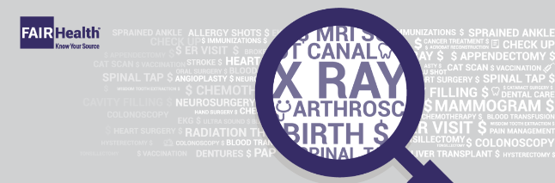 | FH Episodes of Care Benchmarks is powered by the nation’s largest repository of private healthcare claims data, which is continually updated.
9 | [FAIR Health logo with contact info]  Onscreen:  FAIR Health is the only independent nonprofit certified and licensed by the Altarum Institute to operate its PROMETHEUS Payment® model, which is used to identify the services that make up each episode. | Our data can help drive your decisions. View a product demo for yourself and see what FH Episodes of Care Benchmarks can do for you.  To learn more, please contact us at  info@fairhealth.org or call 855-301-3247.

