Wolcott Wheeler – MFS Institutional Twitter Social Media Copy – February-April 2017

https://twitter.com/followMFS?ref_src=twsrc%5Egoogle%7Ctwcamp%5Eserp%7Ctwgr%5Eauthor

- More
Active management = risk management. Stop by booth 121 at @MorningstarInc to hear more about our philosophy #MICUS http://bit.ly/2pDQDvf
0 replies1 retweet2 likes
Reply

Retweet
1

Like
2

Direct message
- MFS‏Verified account @followMFS 26 Apr 2017
More
Grab coffee on us at the coffee bar & stop by booth 121 to explore our perspective on active management. #MICUS http://bit.ly/2qfGNMs
0 replies2 retweets3 likes
Reply

Retweet
2

Like
3

Direct message
- MFS‏Verified account @followMFS 25 Apr 2017
More
Attending @MorningstarInc in Chicago this week? Visit us at booth 121. #MICUS http://bit.ly/2pwZY84
1 reply1 retweet5 likes
Reply
1

Retweet
1

Like
5

Direct message
- MFS‏Verified account @followMFS 24 Apr 2017
More
Only 1/3 of #GenX investors feel they can address financial concerns and meet long-term financial goals. http://bit.ly/2q88y9E
0 replies2 retweets2 likes
Reply

Retweet
2

Like
2

Direct message
- MFS‏Verified account @followMFS 20 Apr 2017
More
Part of an advisor's greatest value is the ability to have tough and honest conversations with clients. http://bit.ly/2o92KzV
0 replies2 retweets3 likes
Reply

Retweet
2

Like
3

Direct message
- MFS‏Verified account @followMFS 20 Apr 2017
More
Susan Kay will share best practices from financial advisers at the Women Adviser Summit in Chicago on 4/26 #WAS2017 http://bit.ly/2oWcYDg
0 replies1 retweet2 likes
Reply

Retweet
1

Like
2

Direct message
- MFS‏Verified account @followMFS 19 Apr 2017
More
How does adding quantitative insight to human judgement impact investment decision-making? http://bit.ly/2ofdYxW
0 replies1 retweet2 likes
Reply

Retweet
1

Like
2

Direct message
- MFS‏Verified account @followMFS 14 Apr 2017
More
Rather than give up on alpha, how can active managers adapt to changing investor demands? http://bit.ly/2ofdYxW
0 replies2 retweets3 likes
Reply

Retweet
2

Like
3

Direct message
- MFS‏Verified account @followMFS 13 Apr 2017
More
With costs rising faster than inflation, James Swanson fears US profit margins will be squeezed. http://bit.ly/2pebVfw
0 replies2 retweets2 likes
Reply

Retweet
2

Like
2

Direct message
- MFS‏Verified account @followMFS 11 Apr 2017
More
Why is MFS turning to #fixedincome to strengthen its #institutionalinvestor business? See @BosBizJournal for more: http://bit.ly/2o3PZTl
0 replies4 retweets2 likes
Reply

Retweet
4

Like
2

Direct message
- MFS‏Verified account @followMFS 7 Apr 2017
More
Certain markets look richly valued – a time for active risk management rather than owning the market. http://bit.ly/2oIbNUA
0 replies2 retweets2 likes
Reply

Retweet
2

Like
2

Direct message
- MFS‏Verified account @followMFS 6 Apr 2017
More
We sorted 300+ pieces of clothing for @RoomtoGrow_Org. Learn more about their important work: http://www.roomtogrow.org
0 replies3 retweets3 likes
Reply

Retweet
3

Like
3

Direct message
- MFS‏Verified account @followMFS 4 Apr 2017
More
James Swanson addressed growing market doubts about Trump’s ability to inspire growth in this @WSJ article: http://on.wsj.com/2oyEfMx
0 replies0 retweets2 likes
Reply

Retweet

Like
2

Direct message
- MFS‏Verified account @followMFS 31 Mar 2017
More
Expectations for market volatility and more dispersed stock prices are an opportunity for active to shine. http://bit.ly/2oIbNUA
0 replies1 retweet4 likes
Reply

Retweet
1

Like
4

Direct message
- MFS‏Verified account @followMFS 29 Mar 2017
More
See what James Swanson had to say in @FT about the challenges facing Trump’s healthcare bill: http://on.ft.com/2nvRbzg
0 replies1 retweet2 likes
Reply

Retweet
1

Like
2

Direct message
- MFS‏Verified account @followMFS 22 Mar 2017
More
James Swanson and Erik Weisman discuss navigating what could be a tricky market landscape. Tune in! http://bit.ly/2nJOfCj
0 replies0 retweets2 likes
Reply

Retweet

Like
2

Direct message
- MFS‏Verified account @followMFS 22 Mar 2017
More
Low-vol strategies can provide a cushioned decline in downmarkets & equity upside participation in upmarkets. http://bit.ly/2nG54JY
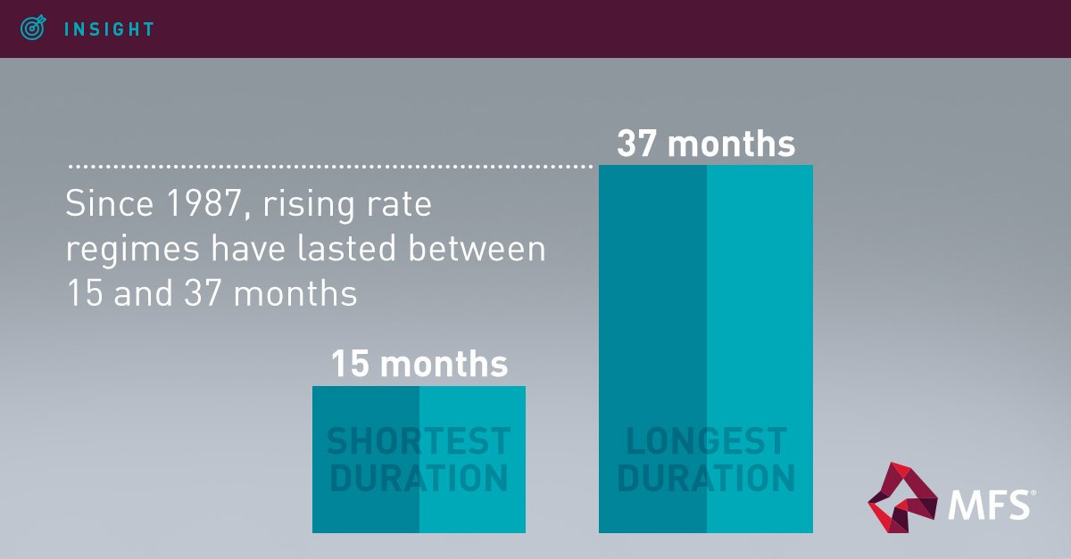
0 replies0 retweets1 like
Reply

Retweet

Like
1

Direct message
- MFS‏Verified account @followMFS 21 Mar 2017
More
See why we think loss avoidance is the key alpha driver for retail industry stocks in the coming years: http://bit.ly/2mGzgpn
0 replies0 retweets0 likes
Reply

Retweet

Like

Direct message
- MFS‏Verified account @followMFS 20 Mar 2017
More
Could Trump’s economic policies hamper U.S. economic growth? Read why MFS’ Erik Weisman thinks so. http://bit.ly/2nKYPFF
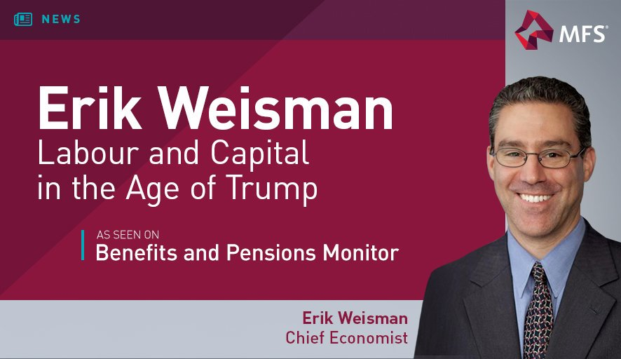
0 replies0 retweets2 likes
Reply

Retweet

Like
2

Direct message
- MFS‏Verified account @followMFS 16 Mar 2017
More
How can you tell if a plan measures up? Hear from MFS at the NAPA summit on March 19-21 in Las Vegas. http://bit.ly/2nwtC94
0 replies0 retweets2 likes
Reply

Retweet

Like
2

Direct message
- MFS‏Verified account @followMFS 15 Mar 2017
More
A strategic allocation to low volatility benefits from the defensive attributes of this investment approach. http://bit.ly/2nG54JY
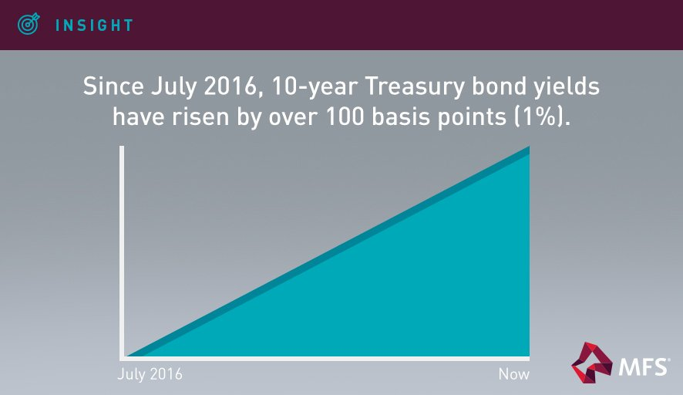
0 replies2 retweets1 like
Reply

Retweet
2

Like
1

Direct message
- MFS‏Verified account @followMFS 15 Mar 2017
More
The Dutch election could be a leading indicator of the strength of Europe’s populist tide. http://bit.ly/2m1et2t
0 replies0 retweets2 likes
Reply

Retweet

Like
2

Direct message
- MFS‏Verified account @followMFS 14 Mar 2017
More
The latest threat to traditional US retailers? Proposed tariffs. 98% of apparel sellers’ goods are imported. http://bit.ly/2mGzgpn
0 replies0 retweets1 like
Reply

Retweet

Like
1

Direct message
- MFS‏Verified account @followMFS 13 Mar 2017
More
Trump faces hurdles in enacting his reflationary policy mix. Read our Market Quick Points for more. http://bit.ly/2n7eWw7
0 replies0 retweets1 like
Reply

Retweet

Like
1

Direct message
- MFS‏Verified account @followMFS 9 Mar 2017
More
Smart beta can add value, primarily through volatility reduction, when factors are combined. http://bit.ly/2lHc5MR
0 replies0 retweets2 likes
Reply

Retweet

Like
2

Direct message
- MFS‏Verified account @followMFS 9 Mar 2017
More
Pilar Gomez-Bravo: Think global; significant growth in global new issue offers a wider opportunity set #PLSAinvest
0 replies0 retweets2 likes
Reply

Retweet

Like
2

Direct message
- MFS‏Verified account @followMFS 9 Mar 2017
More
Pilar Gomez-Bravo: Global credit offers a much larger universe in terms of issuers and market value #PLSAinvest
0 replies0 retweets0 likes
Reply

Retweet

Like

Direct message
- MFS‏Verified account @followMFS 9 Mar 2017
More
Pilar Gomez-Bravo: Going global offers increased diversification & greater flexibility; allows for a more liquid credit exposure #PLSAinvest
0 replies0 retweets0 likes
Reply

Retweet

Like

Direct message
- MFS‏Verified account @followMFS 8 Mar 2017
More
Join us tomorrow in the Learning Zone for Pilar Gomez-Bravo’s “Why Global Credit” at @ThePLSA #PLSAInvest http://bit.ly/2lDOk9T
0 replies1 retweet2 likes
Reply

Retweet
1

Like
2

Direct message
- MFS‏Verified account @followMFS 6 Mar 2017
More
Why do we doubt the sustainability of the #reflation narrative? See our Market Quick Points. http://bit.ly/2n7eWw7
0 replies0 retweets1 like
Reply

Retweet

Like
1

Direct message
- MFS‏Verified account @followMFS 5 Mar 2017
More
We’re seeing less disinflation, but no real signs of higher core inflation to bolster the reflation trade. http://bit.ly/2mg9r1I
0 replies3 retweets0 likes
Reply

Retweet
3

Like

Direct message
- MFS‏Verified account @followMFS 3 Mar 2017
More
Why is a #lowvol strategy well-suited to a strategic allocation? You can see its benefits over a full market cycle. http://bit.ly/2mUizWr
0 replies0 retweets0 likes
Reply

Retweet

Like

Direct message
- MFS‏Verified account @followMFS 2 Mar 2017
More
Increasingly, investors are using sophisticated, factor-based strategies in their portfolios. http://bit.ly/2lHc5MR
0 replies0 retweets0 likes
Reply

Retweet

Like

Direct message
- MFS Retweeted
Chuck Jaffe‏ @ChuckJaffe 27 Feb 2017
More
Hope you caught Jim Swanson of @followMFS on my @MoneyLifeShow: A voice of calm, reason & concern in a noisy market. http://moneylifeshow.com
0 replies1 retweet0 likes
Reply

Retweet
1

Like

Direct message
- MFS Retweeted
Money Life Show‏ @MoneyLifeShow 27 Feb 2017
More
Our show today: Billy Hensley of @NEFE_ORG, Jim Swanson of @followMFS, David Trainer of @NewConstructs and @StephenLMcKee w/the Market Call
1 reply2 retweets2 likes
Reply
1

Retweet
2

Like
2

Direct message
- MFS‏Verified account @followMFS 28 Feb 2017
More
While alpha was elusive in 2016, it was also a year of rising market inefficiencies. Read MFS’ take: http://bit.ly/2mtMUea
0 replies0 retweets0 likes
Reply

Retweet

Like

Direct message
- MFS‏Verified account @followMFS 27 Feb 2017
More
James Swanson lays out seven warning signs that the business cycle is waning: http://bit.ly/2m90DLn
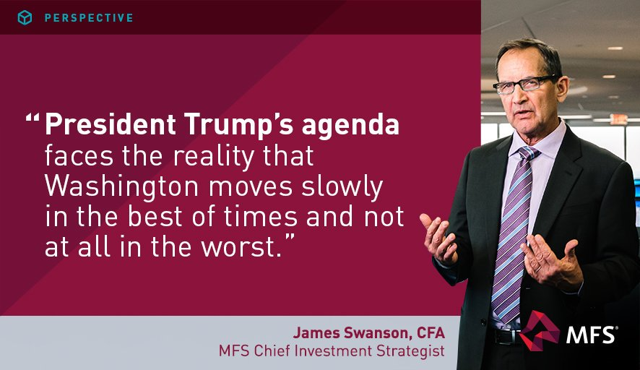
1 reply2 retweets3 likes
Reply
1

Retweet
2

Like
3

Direct message
- MFS‏Verified account @followMFS 25 Feb 2017
More
Smart beta in the limelight: combination factor portfolios usually outperform single factors. http://bit.ly/2lHc5MR
0 replies1 retweet2 likes
Reply

Retweet
1

Like
2

Direct message
- MFS‏Verified account @followMFS 24 Feb 2017
More
Who were last year’s big winners in the Trump rally? The results may surprise you. Click here to learn more: http://bit.ly/2mtMUea
0 replies0 retweets1 like
Reply

Retweet

Like
1

Direct message
- MFS‏Verified account @followMFS 24 Feb 2017
More
The reflation trade is full of hot air; it’s not clear the Trump administration will be able to deliver growth. http://bit.ly/2mg9r1I
0 replies0 retweets1 like
Reply

Retweet

Like
1

Direct message
- MFS‏Verified account @followMFS 22 Feb 2017
More
Our James Swanson is leaning against the reflationary wind. Learn why: http://bit.ly/2m90DLn
0 replies0 retweets2 likes
Reply

Retweet

Like
2

Direct message
- MFS‏Verified account @followMFS 20 Feb 2017
More
What happens to managers who have differentiated views and think long-term? They may outperform. http://bit.ly/2lohQNy
4 replies59 retweets244 likes
Reply
4

Retweet
59

Like
244

Direct message
- MFS‏Verified account @followMFS 18 Feb 2017
More
There are plenty of risks that can derail DC plan participants. Skilled active management can help. http://bit.ly/2lw25Xk
0 replies25 retweets149 likes
Reply

Retweet
25

Like
149

Direct message
- MFS‏Verified account @followMFS 16 Feb 2017
More
How can you avoid overpaying for yesterday’s profits while undervaluing tomorrow’s? See MFS’s ideas. http://bit.ly/2k4gjdc
12 replies104 retweets698 likes
Reply
12

Retweet
104

Like
698

Direct message
- MFS‏Verified account @followMFS 8 Feb 2017
More
Investing in disruptive technology isn’t enough. Investors need to avoid stocks that will be gone in a decade. http://bit.ly/2k4gjdc

