FH Methodology marketing video script

Scene 1

How does FAIR Health arrive at the methodology that generates its benchmark values?

In this video, you’ll learn how FAIR Health took the methodologies used by two of our key benchmark products—FH Benchmarks and FH Relative Value Benchmarks—and merged them into a single methodology to create the FH Unified Medical Benchmarks.

Scene 2
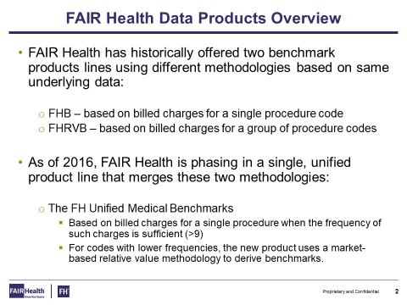

In the past, FAIR Health offered two different benchmark products with two different methodologies, based on the same underlying data for each of the products.

- FH Benchmarks was based on billed charges for a single procedure code.
- FH Relative Value Benchmarks was based on billed charges for groups of procedure codes.

As of 2016, FAIR Health has been phasing into a unified product, FH Unified Medical Benchmarks, which merges these two methodologies into one, to create less confusion in the marketplace.

The FH Unified Medical Benchmarks are based on billed charges for a single procedure code when there’s enough frequency in a particular geographic area. There have to be at least nine occurrences of a particular CPT code in a given geographic area to create billed charges for a single procedure code.

For codes with lower frequencies, or less than nine occurrences, FH Unified Medical Benchmarks uses a market-based relative value methodology to derive benchmarks.

What’s a relative value? A relative value is a value of measurement that relates one CPT code to another.

But please note—a relative value is not a conversion factor, which is a dollar amount per relative value unit.

Scene 3

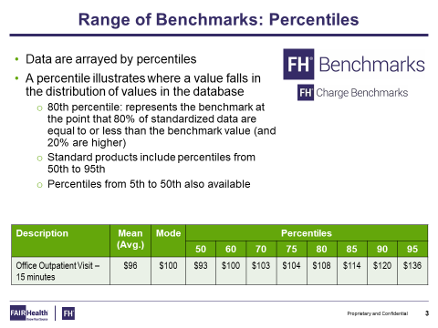

You can see the data are arrayed by percentiles.

A percentile is a value that falls in a distribution of values. For example, the 80th percentile in our standardized data would represent dollar values at the point where 80% of the dollar values are at that level or lower, and 20% of those dollar values are at that level or higher.

Our standard products include percentiles from the 50th to 95th. But you also can access percentiles from 5th to 50th using our Custom Analytics.

Scene 4

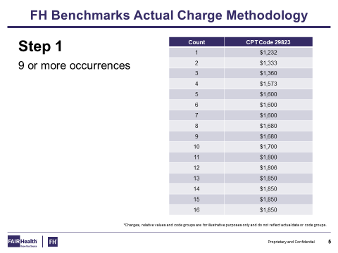

Now let’s delve into a high-level overview of our methodology. The FH Benchmarks Actual Charge Methodology is fairly simple.

If there are more than nine occurrences in a particular geographic area, you simply list those values from lowest to highest.

How do you create a percentile? In this example, we have 16 CPT code values. To find the 50th percentile, you take the number of occurrences —in this case, 16—and multiply it by .50, which would give us 8.
Simply count to the eighth placeholder, and that becomes the 50th percentile. And we can do that for the 60th percentile, 70th, and so on.

Scene 5

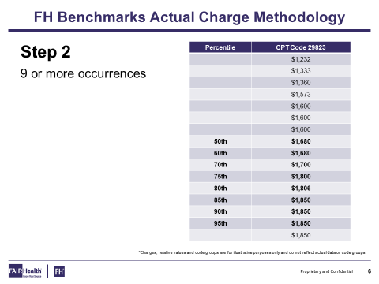

Once we’ve arrayed the charges from lowest to highest and done that simple mathematic equation, we can create the 50th to the 95th percentiles for the benchmarks.
In this example, you can see that the 85th through the 95th percentiles have the exact same value.

If there are low occurrences, and there are a high number with the exact same dollar amount for a specific CPT code in that geographic area, you can have more than one percentile be the same value.

In fact, you can have all the percentiles be the same value if there is enough data in that area that have the exact same dollar amount as a billed charge.

Scene 6

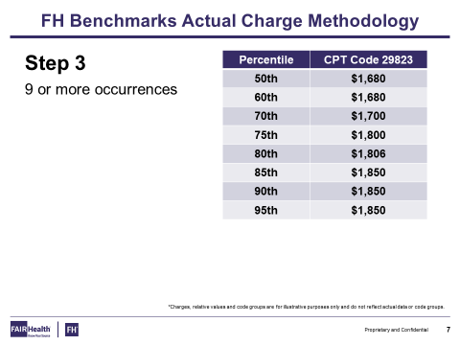

Now we can see the 50th through the 95th percentiles generated by our Actual Billed Charge Methodology.

Scene 7

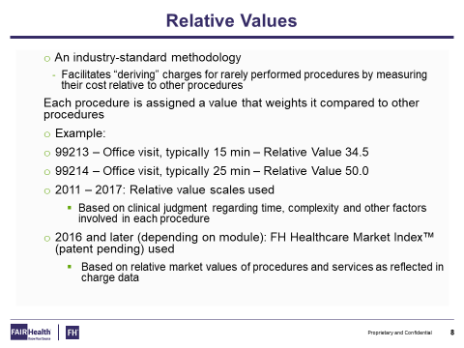

Let’s discuss relative values—before we launch into our discussion of our relative value and conversion factor methodology for those codes with low or no frequency in a given geographic area.

Relative values have been around since the 1950s, when the California Medical Association created them to facilitate deriving charges for those codes that are infrequently performed, by measuring their cost relative to other procedures in that group of codes.

Each procedure code is assigned a value that weights it compared to other procedures. For example, procedure code 99213, which is for a 15-minute office visit, has a relative value of 34.5 because of the time and complexity involved. Code 99214 for a 25-minute visit is assigned a relative value of 50 because of its longer timespan and greater complexity.

From 2011 to 2017, we based the relative value scales used in these products on clinical judgement regarding time, complexity and other factors involved with each procedure.

After 2016, depending on the module, we’ve used the FH Healthcare Market Index. This relative value scale developed by FAIR Health is based on the relative market values of procedures and services as reflected in charge data.

Scene 8

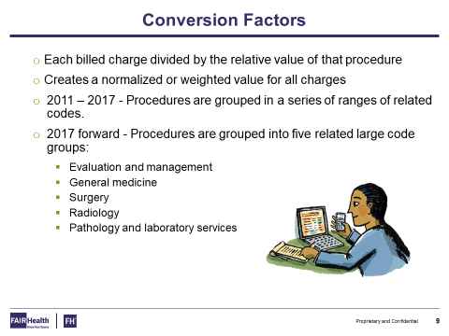

A conversion factor is each billed charge divided by the unique relative value for that specific procedure.
This creates a normalized or weighted value for each of the charges.

From 2011 to 2017, we grouped procedures in a series of ranges of related codes, resulting in many ranges.

Since 2017, we’ve grouped procedures into five related code groups. These are related to the American Medical Association’s CPT Book, which sets out five different groups:

- Evaluation and management;
- General medicine;
- Surgery;
- Radiology; and
- Pathology and laboratory services.

Scene 9

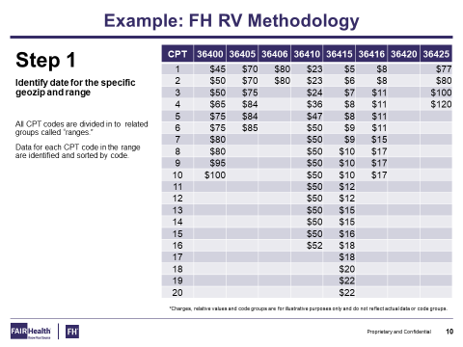

To explain this new relative value methodology, in this example, we’re using a small set of codes, instead of the five large sets we just described, to make it easier to explain.

In this example, here we have CPT codes 36400 to 36425. Each of these codes has billed charges listed underneath. We should add that these codes are for illustrative purposes only and don’t reflect any data in our data set.

After we arrive at values for each of the codes and align them underneath from lowest to highest, you’ll notice that code 36420 has zero occurrences, and several codes have less than nine occurrences. For instance, 36405 has six, 36406 has two, and so on.

Scene 10

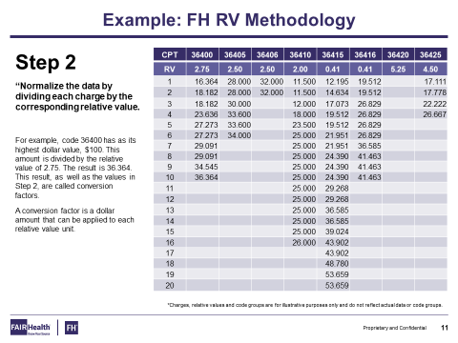

Once we’ve aligned each of the billed charges under the codes in this particular geographic area, we can take, for example, code 36400, which has a billed charge of $45 and a relative value of 2.75.

You simply take the billed charge of $45 and divide it by the relative value, 2.75, to arrive at the conversion factor for that code. In this case, that turns out to be 16.364.

We do that for each of the CPT codes and each of the dollar amounts, and then divide them by the relative values specific to the CPT code.

Scene 11

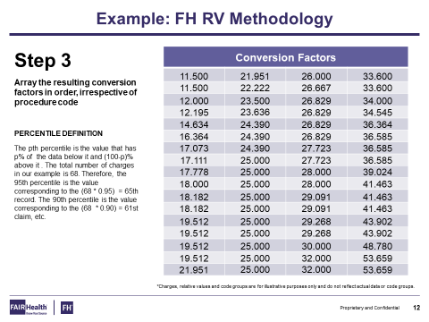

Once we’ve created conversion factors for each of these codes, we align these conversion factors from lowest to highest, regardless of the procedure codes—we take the procedure codes out of the equation.

Now we want to find the conversion factor for each of the percentiles from the 50th to the 95th. This will be the dollar amount used per relative value unit for this group of codes in this geographic area.

Here’s how to create a conversion factor that relates to each percentile. In this example, we have 68 conversion factors. If I want to find the 95th percentile conversion factor for this group of codes and geographic area, we take 68 and multiply it by .95—that equals the 65th record.

We would then count to the 65th record, and that would become the conversion factor for the 95th percentile for this group of codes and geographic area.

Scene 12

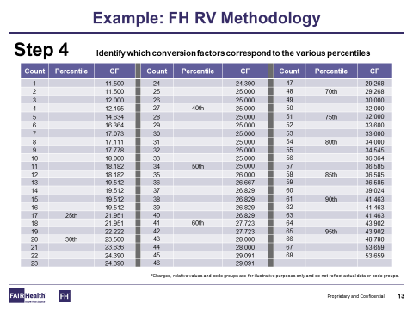

Here we can see where each of the conversion factors fell in this example from the 25th to the 95th percentile. Once we’ve figured out which conversion factors we’re going to use, we simply multiply those conversion factors by each unique relative value that had less than nine occurrences in each geographic area.

In our earlier slide describing Step 2 of this process, we showed that even though 36420 had zero frequencies, there was a relative value of 5.25 established.

By taking that relative value of 5.25 and multiplying it by the 25th percentile’s conversion factor of 21.951, we can create a derived benchmark of $115 at the 25th percentile. And it goes up from there.

Through these high-level examples, you can see how to create a benchmark using relative value methodology.

Scene 13

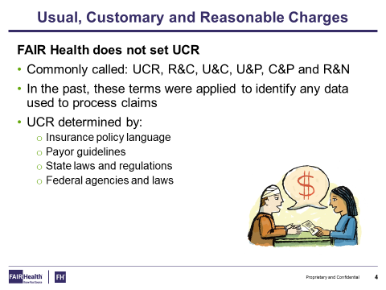

The last topic we need to discuss is usual, customary and reasonable charges. This is often called UCR.

UCR is not set by FAIR Health. It’s been called many different things:

- Reason and customary;
- Usual and customary;
- Usual and prevailing;
- Customary and prevailing; and
- Reasonable and necessary.

In the past, these terms were applied to identify any data used to process their claim set.

But UCR is really determined by insurance policy language, FAIR guidelines, state laws and regulations, and federal agencies and laws. It’s not a value that falls within FAIR Health’s purview.

Scene 14

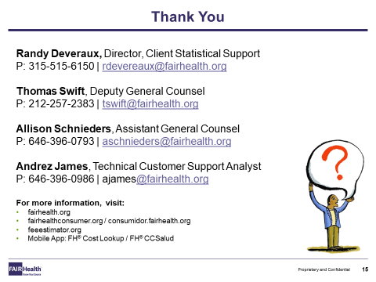

Now you can see how we merged the two methodologies employed by FAIR Health in FH Benchmarks and FH Relative Value Benchmarks to formulate the single methodology behind FH Unified Medical Benchmarks.

Do you require client statistical support, legal support, or technical support in using FAIR Health’s methodology? If you have any questions about our methodology, please feel free to contact the person listed on this screen whose specialized field of knowledge coincides with the scope of your inquiry. We’ll be happy to help.

