Induction for Non-Executive Members of the Board of Directors of
OAO “MMC “Norilsk Nickel”
Towards Global Best Practices
Draft report

Table of Contents

Table of Contents 2

Executive Summary and Results 3
Objectives 4
Review of the Company’s Existing Practices 5
Best Practices in Metal and Mining (Based on the Big Three) 8
Global Best Practices Error! Bookmark not defined.

I. Induction Training 9
A. Initial Orientation Error! Bookmark not defined.
B. Industry Expertise 24
C. Corporate Governance, Legal and Regulatory Workshop 24
D. Accounting Academy Error! Bookmark not defined.
E. Committee Membership and Chairmanship 13 Error! Bookmark not defined.
II. Organization, Roles and Processes 24

Appendices 27
1) Induction of a New Director: Checklist 28
2) Sample of an Induction Session 31
3) Sample of a Site Visit Schedule 32

Executive Summary and Results

Research has shown the following:
An induction is a common practice across most of the Organization for Economic Co-operation and Development (OECD) countries and is a mandatory practice under the UK Governance Code and Australian Securities listing rules. In addition to the listing rules, a number of countries such as Australia, Chile and Germany make a mandatory formal induction program a common practice.
In this document, we propose our recommendations on adapting an induction that can be flawlessly integrated into the Company’s corporate governance system. We view the induction as a bridge between the process of nominating new directors and evaluating Board of Directors (BOD) performance.
Based on the results of the analysis, we advise the Company to undertake the following:
- Establish a proper framework for the induction
- Make the induction mandatory for new non-executive directors
- Ensure that completion of the induction forms a part of the evaluation of the Board
- Disclose results of the induction in the Company’s annual report or in its corporate governance statement
- Review the induction periodically to ensure whether it needs to be revised based on the Company’s needs in the future.

The induction should be structured so that directors spend two days in Board workshops and one or two days on a Norilsk onsite visit.

induction program:

Objective:
The induction aims to provide newly elected non-executive members of the Board of Directors (“Directors”) with the information and relevant expertise that they will require to become as effective as possible in performing their fiduciary responsibilities within the shortest practicable time. Induction should function to achieve the following goals:
- Make the BOD more efficient in performing its fiduciary duties.
- Build an understanding of the nature of the Company, industry and business operations
- Establish a relationship with other directors within the Company’s Board and senior management
- Help understand the Company’s culture and strategy.
By successful completing the induction, the directors can actively participate in the decision-making process, thus contributing to creating shareholder value. In addition, during the annual evaluation process, completing the induction can be served as an element for personally evaluating each director.

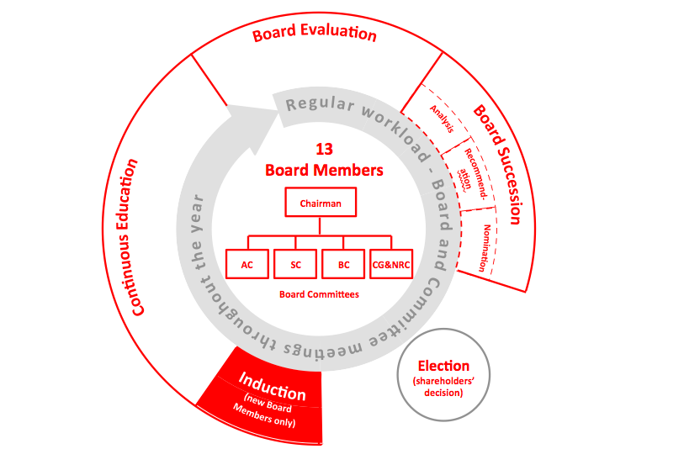

Structure of the Induction:
The induction should consist with two parts: seminars and site visits. The Aneta McCoy Advisory Group (AMAG) suggests dividing the seminars into two separate parts. The first part of the induction should focus on a general overview of the induction (“seminar”) for all new directors, and during the second day of the induction, it also should focus on those directors who plan to chair or become a member of a committee. The induction should consist of the ten (10) key building blocks:
- Seminar
- Board committee workshop
- Management introduction
- Corporate governance, legal and regulatory workshop (including Board self-governance)
- Corporate reporting
- Industry expertise
- Site visits
- The organization, roles and processes of the induction program
- Disclosure.

The induction process should ensure that the following elements are considered.

- The values and expectations of the Board are highlighted.
- The key roles of the Board are discussed and what these mean in terms of what is expected of directors.
- The key legal requirements of directors should follow are discussed, and particularly what this means in terms of behavior and what is expected of the Board.
- The induction program should also give directors the ability to assess their own knowledge in key areas and to seek further clarification and knowledge where needed.

Figure: 1 (Building blocks of the induction)

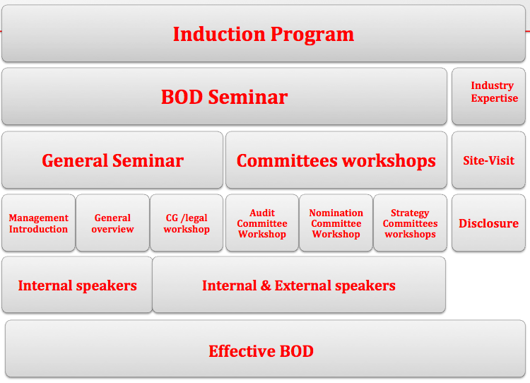

[Regarding the table above:
- All words should be capitalized--for consistency
- “Committees workshops” should be “Committee Workshops”
- “Site-Visit” should be “Site Visit”
- “GC/Legal workshop” should be “Corporate Governance/Legal Workshop” – WW]

Review of the Company’s Existing Practices

Current framework of the induction program:
We have been informed that there is no formal induction program in place at the Company, and all new non-executive directors inquire about the Company’s operations and site visits on an ad hoc basis.
Following the March 2013 Extraordinary General meeting (EGM), Mr. Penny, Prinsloo and Bugrov visited the Company’s production sites in Norilsk and met with operational managers to become acquainted with the major production facilities and business processes.

In summary, they undertook:

- A trip to Talnah
- Visited the underground mine facilities at Komsomolski
- Visited facilities on the surface of the Skolistaya and Komsomolsky mines
- Visited the BC-10 and SCS-1 mines at Komsomolski
- Visited the Talnakh enrichment plant
- Visited the crushing, grinding, and flotation plants at the Talnah-ray concentrator
- Visited the copper plant
- Visited the museum in Norilsk
- Visited the redistribution metallurgical plant at Nadezhda.
Because of the Company’s lack of an induction program, newly elected directors raised many basic questions, demonstrating that directors could substantially improve their level of business understanding and familiarity with the industry. The following areas seemed to be weak:

- Global industry practices, technology and operational processes
- Russian legal and regulatory environment (including corporate governance)
- Accounting methodology and corporate reporting practices
- Environmental, health, safety and sustainability issues.

Best Practices in Metal and Mining (Based on the Big Three)

Based on the results of the corporate governance assessment conducted in 2013, we have identified that BHP Billiton, Rio Tinto, and the Anglo Potash Corp. demonstrate the best corporate governance practices. This section contains a brief description of their approach to induction training for members of the Board of Directors.
Responsible parties:
The Chairman of the Board should take the lead on induction, while the corporate secretary should facilitate the induction program under the direction of the Chairman. The time needed to complete an induction will depend on the company, its size and complexity.
The induction should be designed to emphasize the ongoing continuous education and development program for directors, as one should transition smoothly into the other.
The corporate secretary, the Corporate Governance Committee, and the Head of Legal should support the company’s legal counsel to ensure that the Board is fully briefed on all of its legal and regulatory responsibilities.

Item | BHP Billiton | Rio Tinto | Potash Corp
Does the company have an induction program? | Yes | Yes | Yes
Is the induction program mandatory for new directors? | Yes | Yes | Yes
Does the company publish a separate statement on the induction in its website? | Yes | No | No
How often do BOD members make site visits? | 2 per year | 1 per year | No Disclosed
Does the company publish the names of directors who attended the induction? If yes, in what form? | No | No | No

I. Seminar
Objective:
The seminar should provide important information about the Company and the Board’s roles and responsibilities. It should also serves to build a working relationship among Board members that promotes ongoing support so they can agree how they will carry out their fiduciary responsibilities.
When:
The induction for new directors should take place within the first month of their appointment. The seminar should contain a management introduction, an overview of the company and its operations, and the Corporate Governance and Legal workshops for the Board.
The seminar should focus on the following reference points:

- Corporate governance
- The duties, obligations, powers, composition and operation of the Board of Directors
- The industry and the market
- The Company’s business
- The Company management
- Control and risk systems
- Sustainability and ethics in business administration
- Membership and chairmanship responsibilities
- Research, development and technological innovation
- Russian legislation
- Capital markets activities

A. Information and Materials:
New members of the Board should have an immediate access to the data room (the Company’s central data collection and storage area) and be able to access monthly information, including actual financial results, investor relations (IR), and reports from executive directors regarding their areas of responsibility; this will give Board members an opportunity to develop an understanding of the views of major investors. From time to time, the Board should receive detailed presentations from management on matters of significance or new opportunities such as financial plans, including budgets and forecasts that are regularly discussed at Board meetings. In addition, the investor relations team should circulate presentations every quarter on share performance against global peers, major indices, and how the shareholder base has changed prior to the previous quarter.
Available materials should typically help Board members to:
- Know the people:

List of all board members, their terms, and their contact information; a short biography of CEO and executives; and an organizational chart.

- Know the responsibilities:

- A description of board member responsibilities
- Job descriptions of the officers; all committee charters and a list of members
- A governance handbook.

- Know the legal framework:
- Articles, bylaws
- Board-related policies
- Liability insurance.

- Know the organization:

- A short organizational history
- Key historical events
- A mission statement fact sheet about the industry
- The manual should be kept current by updating needed pages electronically or in hard copies.

Since the BOD members’ time is fairly limited, they do not have time to surf the Company’s website for the information about the Company they need to know. The company’s IT department should design an application specifically for the BOD and corporate secretary so they can access it anytime from any location. It will be beneficial for the BOD if an IR team uploads presentations and reports of shareholders meetings to the drive/portal.

A short list of questions for the BOD

Although above-mentioned documents are essential to bring the directors up to speed with information, there is a risk that a director will not be ready for the Board’s discussions and decision-making. To make a learning curve of a new director as effective as possible, a strategic and conscious governance induction program should focus on these key behaviors and attributes:

- Highlight the Board’s values and expectations.
- Discuss the Board’s key roles and what these mean in terms of the director’s expectations.
- Discuss the director’s key legal requirements, particularly what this means in terms of the Board’s behavior and expectations.
- The induction should also allow directors to self-assess their knowledge in key areas and seek further clarification and knowledge where needed.

D. Management Introduction:
We recommend that senior management host a welcoming session for new board members to make them comfortable and introduce them to NN. During the management introduction, we encourage that the following executives should attend and give a short introduction:

Member of Management Team and Chairman | Objective
Meeting with Chairman | - Explain the organization’s governance framework  - Discuss the role of a director in the organization and what specifically is expected of the Board  - Deliver an overview of strategic direction and key initiatives
Meeting with the CEO | - Deliver an overview the CEO’s role in the corporate governance framework  - Discuss the organization’s strategic direction and initiatives; strengths, weaknesses, opportunities, and threats (SWOT), and key issues  - Summarize operations  - Introduce key members of the management team
Meeting with the CFO | - Discuss the company’s capital structure  - Outstanding equity and debt  - Discuss the organization’s financial structure and reporting format  - Review current performance and key items  - Discuss the dividend policy and its sustainability.  - Discuss capital expenditure (CAPEX) and its breakdown
Meeting with the COO/Head of Strategy | - Overview of the company’s strategic plan  - Overview of the company’s commodity exposure [is there a reason to bold this? Is it super-important? If not, it should be unbolded -- WW]
Meeting with the Chief Legal Officer | - Overview of the Company’s regulatory framework
Meeting with Corporate Secretary | - Discuss a schedule for next year's board meetings, refine the board operations calendar.  - Discuss the Company’s approach to Board process and involvement  - Ongoing discussions on the director’s role and responsibilities  - Available to answer seemingly obvious questions

B. Legal and Corporate Governance workshop

The second part of the seminar should be dedicated to a legal and regulatory workshop and a discussion of corporate disclosure.
The primary objective of the legal and regulatory workshop is to outline directors’ fiduciary duties and current legal issues. The internal/legal counsel should ensure that new directors are fully briefed on legal and regulatory responsibilities. The legal counsel should cover the following areas:
- Directors’ responsibilities under Russian law
- Board ethics
- An explanation of the basic framework of the Russian securities rules and civil code
- Liability insurance
- Any significant litigation the Company is involved in or may become involved in.
This workshop should provide an overview of the above issues and give directors practical experience in how regulatory and corporate governance frameworks are developed. It should also help facilitate the exchange of knowledge among existing and new board members and provide them with an understanding of the various aspects of establishing a governmental, legal and regulatory framework.

C. Corporate Reporting

Importance:
The board of directors has ultimate responsibility for information disclosure, since the conventional notion is that directors’ responsibility is to improve the quality of corporate disclosure. One of the most critical requirements of the director’s “duty of care” is to understand the Company’s financials and challenge the management if necessary. In practical world, due to time limitations, many new directors rely on information provided by the organization’s management team and external consultants. However, such reliance does not release a new director from the due diligence required by the board’s responsibility necessary to perform his or her fiduciary responsibility.
Objective:
To gain a proper understanding of how the Company generates its revenue, a new director should become familiar with the Company’s operations, including products and services. Once that knowledge and understanding are obtained, AMAG encourages that a new director spend time to read and understand the Company’s financial statements, especially those members who will be chairing or becoming a member of the Audit Committee.
The induction program should cover briefings on the scope of the internal audit function and the role of the Audit Committee, meetings with the external auditor, and other areas in the director’s area of responsibility.
Structure:

Corporate reporting should be held on the second day of the seminar. In addition, we encourage that the CFO or Head of Treasury attends those meetings and explains the Company’s view on its financials.

- The Corporate Reporting workshop should be designed as a part of the two-day orientation program.
- If a new director is appointed to perform his or her duties in the Audit Committee or Budget Committee, the Corporate Governance Committee and the corporate secretary should create a new agenda that includes additional meetings with the CFO/Head of Treasury and external auditors.
- The corporate secretary should be responsible for communicating such briefings internally.

II. The Committee Membership Workshop

The primary objective of the Committee Membership workshop is to ensure that new directors stay on top of current trends, legislation, regulations, and risk management. The Company should develop and manage an education program for directors who are either chairmen or members of a committee. We view such workshops as a part of continuous education that will be outlined in a separate report. As part of the induction, each member or chair of a committee should spend time to understand their primary responsibilities and work out a plan for collaboration between Executive Management and external advisors, depending upon what role a director committee will play in a given committee.

Structure:

We suggest that the Committee Membership workshop should be held during the second half of the seminar’s second day. This part should conclude the first half of the induction.

Key objectives of each committee:
- Audit and Risk Committees:

Since the Audit and Risk Committees carry out some of the most rigorous obligations before shareholders and regulators, the chairmen of the Audit and Risk Committees should have accounting or financial expertise to perform their fiduciary responsibilities. We are strongly convinced that any type of induction program cannot help a person reach the same level of expertise in accounting as a person who comes from the accounting or financial area. As a result, we strongly suggest the Company consider appointing a Chairman who has a strong accounting or financial knowledge. The induction program for Audit and Risk Committee members and its Chair is designed to promote directors’ understanding of the following:
Area of Focus 1: Understanding Roles and Responsibilities:
- Management’s responsibilities and obligations to the Audit Committee
- The Company’s reporting methods under Russian and International Financial Reporting Standards (IFRS) accounting standards
- The Audit Committee’s charter and what investors and regulators expect of it
- The role and responsibilities of internal auditing, including the scope of its charter
- An understanding of the relationship framework among the Audit Committee, the CFO/Head of Treasury, and the Company’s external auditors
- An understanding of how the external auditor performs its work and how its reaches its conclusions on the Company’s financial statements, related disclosures, and internal controls.

Area of Focus 2: Understanding Risk Management:

- The main principles of the Company’s risk management (CRM)
- The principles of internal controls and the system in place to maintain internal controls at the Company
- The principles of the internal compliance system.
Area of Focus 3: Understanding the consolidation and reporting of financial results
- Norilsk Nickel’s processes for consolidating financial results
- Each section in a financial statement, including the Notes, Management Discussion and Analysis (MD&A), etc.
- What is considered “material” in the financial statements?
Area of Focus 4: Understanding risk recognition and assessment
- A risk assessment of the financial statements’ accuracy
- Red flags that may indicate a problem with the financial statements
- The level of risks related to compliance with international tax, human resources, and business practices laws and regulations.

Area of Focus 5: Understanding capital markets activities
- Dividend policy and its sustainability
- FX exposure and a discussion of hedging tools
- A briefing on the Company’s depositary receipt (DR) program and DR-related arrangements with a depositary bank.

The induction program’s structure relating to the Audit and Risk Committees:
We suggest that a Chairman or member of the Audit Committee must attend the Corporate Reporting and Committee Membership workshops. All members of these committees should spend time with external auditors to foster communication flow and a level of understanding of the Company’s reporting.
We have attached a tentative agenda in Appendix 3.

Nomination and Corporate Governance Committees:
Duties and Responsibilities
Below are the common duties and responsibilities of the Nomination and Corporate Governance Committees in carrying out their fiduciary functions.
Area of Focus 1: Understanding the Roles and Responsibilities of the Nomination Committee:
- To assess a size and composition of the Board of Directors in light of the Company’s operating requirements.
- To coordinate and assist management and the Board of Directors in recruiting new members to the Board
- To investigate suggestions for candidates for Board membership and recommend prospective directors who will provide an appropriate balance of knowledge, experience and capability on the Board of Directors
- To interact with external executive search firms during the recruitment process.
Area of Focus 2: Understanding the Roles and Responsibilities of the Corporate Governance Committee
- To develop membership qualifications for the Board of Directors and all Board committees, including defining specific criteria for director independence and committee membership
- To monitor compliance with Board of Director and Board committee membership criteria
- The Corporate Governance Committee should evaluate and make recommendations regarding Director compensation levels.
- To identify best practices and develop and recommend corporate governance principles applicable to the Company
- To assess periodically and recommend Board of Director actions with respect to stockholder rights plans or other stockholder protections
- To assist the Board of Directors in fulfilling its oversight responsibility for the Company’s overall risk management program.
Remuneration Committee:
Area of Focus 1: Executive Compensation
- The Remuneration Committee should make recommendations for Board approval on all aspects of CEO compensation.
- The Committee should review corporate and individual goals, including those pertaining to the senior management.
- The Committee should make recommendations to the Board regarding incentive compensation and equity-based incentive plans that require shareholder approval.
- When considering compensation, the Committee should consider the Company's performance, relative shareholder return, the value of long-term incentive compensation given to the CEO against the Company’s peer group, and the financial rewards given to the CEO in past years.

Area of Focus 2: Review of Policies and Procedures
The Committee should review and evaluate the Company’s corporate governance policies and procedures, including
- Policies embodied in the Company’s Code of Conduct regarding the development of new policies and procedures
- Information posted on the Company’s website regarding the Board’s rules of procedure and applicable corporate governance guidelines.

Suggested Responsibility Matrix
Item | Human  Resources | Legal/ Company Secretary | Senior Management |  | Remuneration Committee | Board of Directors | Share-  holders
Remuneration policy and strategy | Recommend |  | Recommend  Monitor effectiveness and implement policy  Recommend new improvements to enhance alignment with strategy | Approval  Oversee and review the effectiveness of policy and strategy  Report to board |  | Final approval | Non- bidding vote
Structure and pay mix | Recommend | Consult | Consult | Recommend  Recommend equity-based remuneration structures  Recommend executive incentive to participate in equity plans |  | Final approval | Approve
Performance metrics for variable pay | Recommend | Consult | Recommend  Recommend variable remuneration performance conditions to align with company strategy  Undertake analysis and modeling to test implications  Provide actual performance data for the performance period | Approval  Approve performance measures  Set performance targets  Approve extent to which targets have been achieved  Review performance data for the performance period |  | Final approval | Non bidding vote (?)  [To be clarified later. – WW]
Non-executive director fees |  |  |  | Formulate |  | Recommend | Final approval

Strategy Committee
Area of Focus 1: (Strategy)
- To review, assess and advise on the Company’s operational strategy
- To monitor the implementation of the Company’s strategy approved by the Board
- To review, assess and advise on the Company’s information technology (IT) strategy before its annual submission for approval to the Board
- To identify and advise management on new business opportunities outside the Company’s current activities
- To review proposed acquisitions/sell-offs and the disposal of companies, assets and businesses before submission for approval to the Board;
- To review and advise on off-shoring and outsourcing arrangements
- To advise the Chairman and CEO on matters of corporate activity relating to the Company or its competitors
- To review the annual strengths, weaknesses, opportunities, and threats (SWOT) analysis of the Company.
Area of Focus 2: Health, Safety, and Environment (HSE)
- To review the development of guidelines for managing sustainable development and socio-political risks, including those to safety, health and the environment
- To review the Company’s performance and progressive implementation of its safety and sustainable development (S&SD)
- To receive reports that cover issues related to material sustainability risks and the Company’s liabilities
- To monitor key indicators, learn from incidents, and where appropriate, ensure they are communicated throughout the Company
- To monitor local and international regulatory and technical developments in the field of S&SD.

Budget Committee:
Area of Focus 1: Business Planning and Internal Audit
- To assist the Board of Directors with the preliminary review of matters and the development of recommendations to define policies relating to finance, budgeting, and business planning. (Source: Company’s 2012 annual report
- To review the scope, resources, results and effectiveness of the Company’s internal audit department.

 | Nomination and Corporate Governance Committees | Audit Committee | Remuneration Committee | Strategy Committee | Budget Committee
Meeting with CFO and Head of Treasury |  | Yes |  |  | Yes
Meeting with COO & Head of Strategy |  |  |  | Yes
Meeting with external consultants & auditors | Yes | Yes |  | Yes | Yes
Meeting with HR and Head of Legal | Yes |  | Yes
Meeting with committee members or the chair of a committee | Yes | Yes | Yes | Yes | Yes
Outline of a plan for future collaboration | Yes | Yes | Yes | Yes | Yes
Meeting with the Head of Safety and Environmental Affairs |  |  |  | Yes

III. Industry Expertise

Objective:
The new directors should become familiar with the Company and its industry if they would like to challenge management on strategic decisions. As one of the induction program’s main objectives, directors should know the industry’s dynamics and how companies in this commercial sector generate value, among other issues. Therefore, new directors should spend as much time as required to learn and understand the Company’s operations and its market strategy.
Structure:
New directors should always bear in mind the following elements regarding the Company and their industry expertise:
- Their understanding the Company’s short-, mid-, and long-term strategy
- The latest trends in the metal and mining industry
- What kinds of opportunities exist for the Company?

Note: When learning about the industry and company, new directors should understand the Company’s customer segment and its product categories that have experienced the most growth in recent years. We encourage that management include this topic during one of its presentations.

- How is the competitive landscape evolving?

Note: For directors, it is imperative to understand recent gains and losses by core competitors and their decisions that have driven those changes to understand the Company’s positioning in the market. New directors should understand who the next generation of competitors might be in the near future.

- What kinds of uncertainties exist for the Company and industry? Which uncertainties could cause disruptions or opportunities for the Company?
- Are the Company’s resources aligned with new opportunities?
- Am I truly familiar with the Company’s dividend policy and its sustainability?
- Do I understand the Company’s current and future CAPEX (capital expenditure) strategy?
Directors must evaluate:
- whether the Company’s portfolio is constantly rebalanced by forward-thinking investments
- whether businesses are divested before investors suggest it
- whether the CFO asks challenging questions about the trajectory of even high-profit core businesses, and
- whether the Company sees potential assets for acquisitions well before other potential buyers to avoid multiple bidder situations.

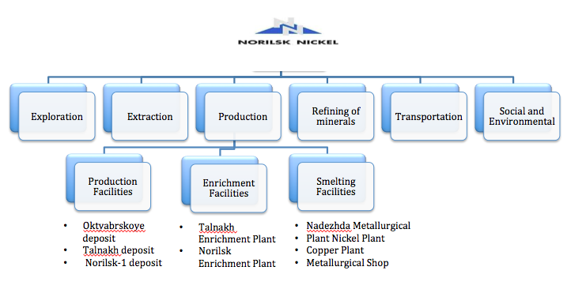

Site Visit
Objective:
Site visits for new directors will give them greater insight into the challenges faced by the Company’s operations and strategy and facilitate better decision-making by the Board. As part of their induction, directors are highly encouraged to visit the Company’s operations so they can review the Company’s business from an independent perspective.
To understand the Company’s nature, the directors must to become familiar with the Company’s operating facilities and speak to responsible people involved in the Company’s day-to-day operations. By successfully completing a site visit, new directors will be able to gain a broader perspective of the business and its operations so they can perform their fiduciary duties.
When:
During the first month of a new director’s appointment, the corporate secretary, with the Corporate Governance Committee’s help, should schedule an onsite visit for directors and meetings with members of the operations management.
Appendix II contains a proposed structure of the site visit. In addition to business operations, the new directors should begin to understand key layers of the organization by meeting with executives who present to the Board, direct reports of the CEO and CFO, and succession candidates.
Must See:
We believe that an agenda for a site visit should flow in line with the supply operational chain model. If new directors are introduced to the Company’s operations via the supply chain’s process-modeling components, they will be able to understand complex elements of the operations in a simpler way. We want them to comprehend:
- Exploration: The directors should understand the processes of raw materials that procure goods.
- Production: The directors should understand the processes that transform raw materials to a finished state to meet planned or actual demand.
- Transportation: The directors should understand the processes that provide finished goods and services to meet planned or actual demand, including order management, transportation management, and distribution management.
- Social and Environmental: The directors should become familiar with the Company’s social and environmental framework. It is imperative for directors to understand the risk assessments that the Company takes to provide to its employees with safe and healthy environment.

Where: Polar Division in Norilsk
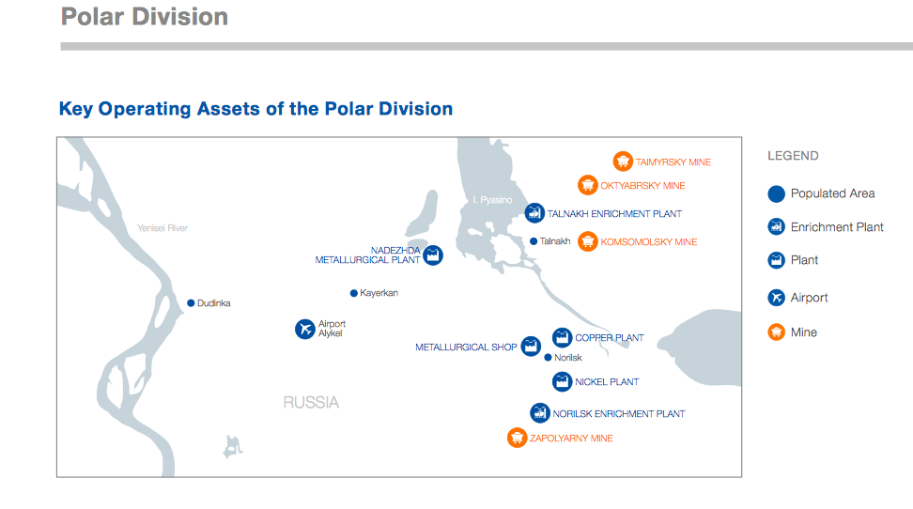

Disclosure:
The Company should mention the successful completion of onsite visits in an annual corporate governance section of the annual report or in separate corporate governance statements. Shareholders appreciate it when directors gain new knowledge and experience to better protect their interests. We have analyzed top FTSE 100 companies by market cap and identified those companies that disclose the completion of site visits by non-executive board of director members in annual reports or corporate governance statements.
Below is a sample screenshots on how companies publish results of induction programs in their annual statements.
Areas of focus during the initial site visit(s)
a. Company background:
For new directors, it is imperative to understand when the Company was formed, for what purpose, and what may have changed since its establishment. Also, it is important for them to know: has the Company made any acquisitions or closed down any significant operations? Have there been any changes in its operations or in the geographical areas served?
b. Description of business operations:
We assume that prior to a site visit, a new director will have a good idea of the Company’s business. However, there is nothing more valuable than a one-on-one conversation with those directly working in the business’ operations. We suggest that a director should be able to answer the following topics:
- What are the Company’s strengths and weaknesses?
- How will the Company’s operations be different in the future?
- How does the Company perceive the industry and where it fits in?
- What does the Company plan in capital expenditures, divestitures, R&D (research and development)?
- Does the Company have intangible assets such as proprietary products and services?
c. Operations:
Directors should understand the following areas of the Company’s operations:
- Industry: Comprehensive briefings on the commodities, assets and markets in which the company operates
- Materials: Understand of the value chain of the company.
- Labor: What is the cost of labor? What is the employee turnover at the company?
- Plant and equipment: What method does the Company use to treat the depreciation of fixed assets? Is the equipment likely a source of future cost savings or cost increase?
- Inventory: Directors should view where the inventory is maintained and inquire about inventory turnover and quality compared to the industry. Could there be excess inventory on the books or valuable inventory written off?
- Markets and marketing: Is the industry market growing or shrinking? Who is the competition? Are customers concentrated? What share of the market does the Company have? What are the latest trends in the industry?
d. Non-operational responsibilities
We highly encourage that new directors should focus on non-operational responsibilities. Management should provide comprehensive briefings on health, safety, environment and community (“HSEC”) issues and public policy considerations.

V. Organization, Roles and Processes of Induction program

The Role of New Directors:
New directors are responsible for devoting their time to receive a comprehensive, formal and tailored induction, which should extend beyond the boardroom. If they take extra initiatives, such as partnering a non-executive director with an executive board member, it may accelerate their understanding of the main areas of business activity, especially in areas involving significant risk. New members of the BOD should visit and talk with senior and middle managers in those areas.
The Role of Corporate Governance Committee:
Prior to electing new directors, the Nomination Committee should meet with the Corporate Governance Committee to share a list of nominees and their set of skills. This is an essential step, since the Corporate Governance Committee will be responsible for executing the induction program and preparing the plan.
The Corporate Governance Committee should be responsible for board orientation, self-assessment and continuing education. There should be a clear communication between the Corporate Governance Committee Chairman and Nomination Committee [(corporate secretary ???) this should be clarified. – WW] regarding the induction program’s implementation. Continuing the induction program is a good way to keep the board current on the latest industry trends and the Company’s internal developments. It also allows new directors or less experienced board members to learn from experienced board members, who can share their experience through such training sessions.
The Role of the Chairman
The Chairman is responsible that all non-executive directors receive the initial and ongoing training and development so that they can appropriately perform their duties. The induction program should be discussed at a non-executive directors’ meeting. The Chairman should assume the responsibility to lead the induction program, since it is in his or her interest that new directors receive all appropriate training to perform their fiduciary responsibilities. The Chairman should sign off on the plan and ensure that the induction program is properly facilitated in accordance with internal policy.
The Role of Corporate Secretary:
Based on the UK corporate governance code (directive B:5.1), a company’s secretary is responsible for facilitating the induction program under the Chairman’s direction.

Summary of Roles and Responsibilities
Xxxxx [To come. – WW]
Responsible Parties | Leading Responsibility | Coordination/  meetings/  materials | Budget | Evaluation
Chairman | Yes (at the initial stage) | No | Yes/sign off | Yes
Corporate Governance Committee | Yes | Yes | Yes/prepare a budget | Yes
Corporate Secretary | Yes | Yes | No | No

VI. AMAG’s Recommendations:
Item: | Objective
- Make the induction program mandatory | - We strongly believe the induction program should be adopted as a mandatory program for all new members and then separately for Chairman. Later in this report, we will outline in a greater detail the formal structure and tentative agenda of the induction.
[Azat, did you want to add any other recommendations? -- WW]

Appendices
APPENDICES

1. Preparing an effective Board Handbook

The Company should develop and provide a Board Handbook to all Board members to use as a quick reference. It should consist of three parts: Quick Reference, General Information, and the Board’s Policies and Procedures.

A. Quick reference:  - A description of Norilsk Nickel’s vision, mission and goals  - An organizational chart  - A description of programs and services  - A description of the Board’s role  - Terms of reference for the Executive Committee  - Staff structure and description of major roles  - List of committees (with statement of purpose for each) | B. General Information  - A copy of the company’s bylaws  - Terms of reference for all committees  - The organizations’ most recent Strategic Plan and Operational Plan  - A list of other Board Members and the corporate secretary’s contact information  - A staff listing with contact information  - The latest IR presentation  - Minutes from the last board meetings and AGM/EGM resolutions
C. Board Policies and Procedures  - Codes of Conduct  - Confidentiality agreement  - A statement of Board policies (refer to policies provided in the Board Manual)  - An overview of Directors’ Liability Insurance  - Director’s compensation  - A quick description on meeting procedures  - Conflict of interest guidelines  - Travel remuneration procedures  - Insurance policy (Directors’ liability information)  - Risk Management Strategy  - Media / Public Relations Policy | D. Financial Management  - Up-to-date audited financial statements  - A copy of the current budget  - A copy of the most recent Annual Report  - The most recent income statement

2. A sample Checklist For the induction:

Provide Quick Reference

History of the organization

Organizational / Board / Executive structure

Copy of constitution & by-laws

Vision & mission Statement of the organization

List of Board members / Executives and THEIR CONTACT information

Roles and Responsibilities

Overview of Board member's role:

- A short overview of a Board’s role and a director ‘s legal responsibilities
- Overview of the internal policy/procedure on travel and expenses that can be reclaimed
- Explanation of potential restrictions on outside interests
- Where and how to get an advice if the director has any concerns

Overview of Executive Roles

Overview of committees and their roles:
Copy of minutes of previous several meetings and of any committees on which the director will sit

Discussed expectations for and of new Board members

Overview of Policies and Procedures

Provide new members with Board policies and procedures

Provide new members with committees policies and their roles

Overview of Company
The company's structure; any subsidiaries or joint ventures
- Major elements of the company's business: key customers and markets, contracts, suppliers, etc.
- Overview of the Company’s current performance: financial, budgets and management accounts, key performance indicators (KPIs), and management compensation
- Describe significant litigation the company is involved in or may become involved in
- Supporting material (e.g., marketing brochures, industry magazines)
- Overview of key policies and procedures such as environmental issues and disaster recovery
- Overview of the dividend policy
Provide a copy of up-to-date audited financial statements
Provide a copy of most recent annual report

3. Sample of the Induction Session

Session | Topic | Responsibility | Time
1 | Welcome speech  Explain Board member responsibilities  - Governance responsibilities  - Board structure, by-laws and committees  - Describe processes for selection, election, and terms for officers and members | Chairman of the Board | 1 hour
2 | Legal Issues  The internal/legal counsel fully briefs newly elected Board members on all their legal and regulatory responsibilities. | Chief Legal Counsel | 1 hour
3 | About the Company  - Discuss the Company’s profile  - Organizational structure of the Group | CEO | 1 hour
4 | The Company’s Business | CEO/COO | 1 hour
5 | Review of Metal Markets | Head of Strategy | 1 hour
6 | - An overview of the financial statement and key indicators that the company is using as the benchmark | CFO | 1 hour
7 | - Sustainable development  - Explain the Company’s operations, industry structure, and quality/safety issues.  - Discuss current and future CAPEX (capital expenditures).  - Provide a clear message of the company’s strategy. | Head of Strategy | 1 hour
8 | HSEC | TBD | 1 hour

4. Sample of the Site Visit Schedule

Item | Description | Objective
Timing: | The site visit should be organized within the first month after directors’ appointment. The corporate secretary should review the BOD calendar to prevent any conflict with major corporate events. Since the majority of non-executive members are appointed in June, the site visit can scheduled for the summer.
Length: | 2-3 days. We encourage that new directors spend at least 3 days to meet and become familiar with the Company’s production areas.
Name of facilities
Training materials | The Corporate Governance Committee & the corporate secretary should compile all relevant materials on the Company’s operations and the mining industry. We have been informed that there is a book on Norilsk Nickel and its operations.
Meeting with Operations in Norilsk | During the site visits, new directors should interact with XXXX to obtain knowledge about XXXXX. New directors are expected to read and review the presented materials before meetings with operation managers.

Aneta McCoy Advisory Group
Bolotnikovskaya 36/5
Moscow, Russia 117149
Tel: +7 (909) 918–7197
aneta.mccoy@amadvisorygroup.com
www.amadvisorygroup.com

