BDSO Case Study
1.30.17 V7

# | Video | Audio/Titles
1 | Bridgestone is one of the biggest brands in auto care. But they wanted to future-proof their business and strengthen their brand through digital transformation.  To do that, they realized they had to change the perception customers had of them as an emergency room where you take your car when it breaks down, to a wellness center where your car has preventative maintenance.  This changes a burden into a benefit. | Anne Bologna, Chief Strategy officer, iCrossing
2 |  | To change course, Bridgestone and iCrossing set a goal: to add one new customer every day in every store—and to motivate that customer to spend more on each visit.  We became Bridgestone’s digital quarterback. Our scope included:  - introducing major website redesigns and rebuilds  - using performance media  - adding a robust new social media program.
3 |  | First we migrated Bridgestone to the full Adobe Marketing Cloud, so every interaction was converted into connected data. We created a strategic platform that put user experience first by focusing on mobile devices with seamless engagement across devices.  We redesigned all Bridgestone sites so they shared a common infrastructure and template design  - introducing major website redesigns and rebuilds  - using performance media  - adding a robust new social media program.
4 | 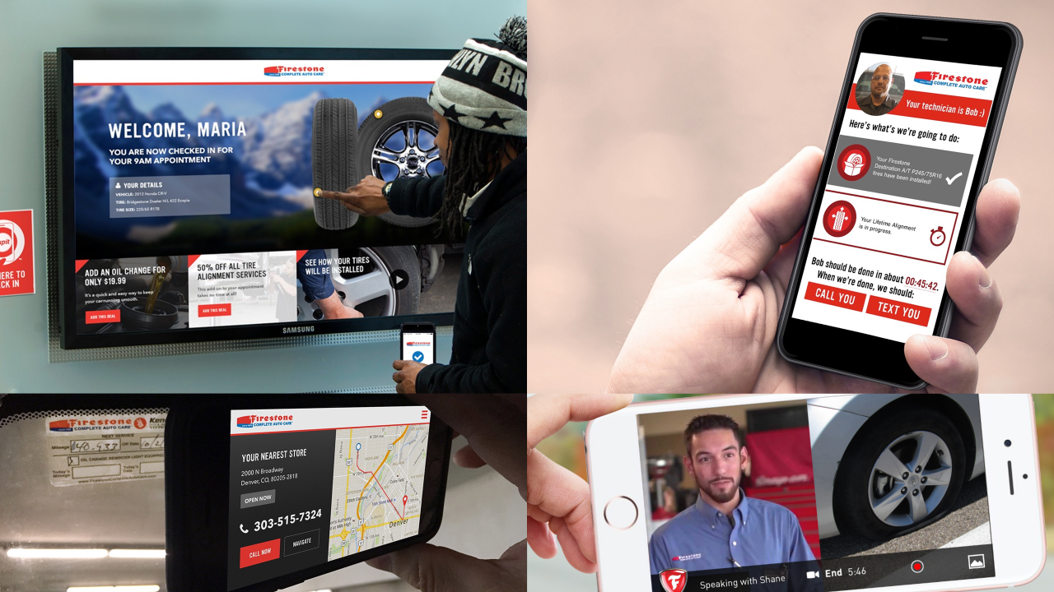  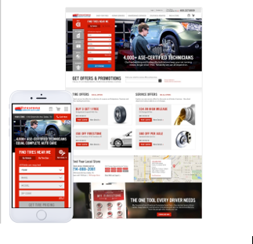[These images, and the ones that follow, are placeholders. Steve might have much better images of specific marketing collateral that show we’re knocking it out of the park.] | We created a strategic platform that put user experience first.  After we crafted a precision marketing program using connected data, we set it into action with a mix of paid, owned and mobile channels.
5 | 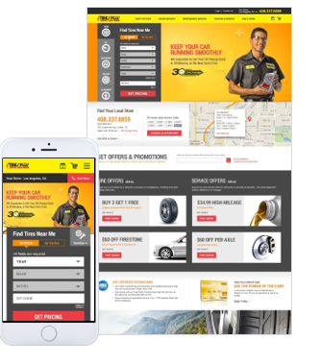  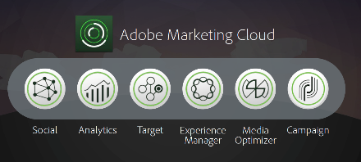 | To reach our customers, we focused on mobile devices with seamless engagement across devices. To improve the user experience, we redesigned all Bridgestone sites so they shared a common infrastructure and template design.  Finally we migrated Bridgestone to the full Adobe Marketing Cloud, so every interaction was converted into connected data to strengthen customer loyalty and demonstrate the wisdom of preventative maintenance.
6 | Shiva discussing how we migrated the websites. 22:42:26:04 - – 22:42:51:00. | [His clip at 23:04:53:15 – 23:04:57:01—“We put in experience first”—is excellent, and since it’s only a few seconds long, maybe we could include it as well.]
7 | A bustling Bridgestone center.  A busy Bridgestone garage, with auto repairmen working.  A woman (minority?) smiling in front of her laptop, smartphone or tablet; she’s interacting with the Bridgestone site. | The results? A 21% increase in call volume, leading to more store visits, meeting and exceeding Bridgestone’s goal of one new customer every day. All for half the previous year’s spend.  Our digital transformation yielded significant results in a matter of months, not years.
8 | Sign in  Download  I think the most surprising part of that is how much has been able to be accomplished in the first year of the partnership  1:00:21:03 - 1:00:21:12  For us, being able to bring both creative, media and technology, that’s where the magic happens.  1:00:56:07 – 1:01:02:20 | Joe Grigsby, Managing Director, iCrossing
9 | [we can splice Herb’s two clips together so they form a complete insight]  The way BDSO works it to align a conversion experience across the purchase journey driven by data  1:04:42:03 – 1:04:51:14  They’re going to be a leader in the automotive aftermarket.  01:18:43:13 - 01:18:43:15 | Herb Sawyer, VP, Strategy, iCrossing
10 | I came across iCrossing—it was a lucky find  1:20:42:19 – 1:20:47:01  You guys stood out as… [include the whole quote captured in the timestamp below; it’s too long to reproduce here] the softer side of marketing.  1:20:58:15 – 1:21:05:20  As we started working more and more with iCrossing … [include the whole quote captured in the timestamp below; it’s too long to reproduce here] …the strategy that brings all the together.  1:21:21:10 – 1:21:33:10  The three ways that iCrossing delivers… [include the whole quote captured in the timestamp below; it’s too long to reproduce here]  01:34:04:20 – 01:34:21:04  The CEO--all the way up to the CEO is excited about work that we’re doing.  01:33:47:08 – 01:33:49:07 | Jennifer Wainwright, [job title], BDSO
11 | [Anne’s segment on 22:31:12:02 – 22:31:29:07, “We were born digital,”

