Solving Pickup and Delivery Planning
If you’re an LTL carrier or a private fleet running multi-stop routes, one of your biggest challenges is routing all those last-mile stops that crisscross the same territory, wasting fuel, money and your drivers’ time. The “impossible” delivery appointments that get your customers sore at you are especially tough. When all the shipments that need to be delivered today have yet to arrive at the terminal, you need a tool that makes a forward-looking plan with realistic assumptions and slack to accommodate pickups later in the day.
But paradoxically enough, LTL carriers have adopted state-of-the-art pickup and delivery tools at a very low rate. Some commercially available routing systems rely on fixed-route boundaries (requiring manual adjustment after optimization), and some make automated optimization decisions that fall short of what an advanced human user can do.

Some LTL companies still use “green screen” routing systems, which cannot show the user the big picture like map-based systems. Carriers that have developed in-house solutions often lack the mathematical modeling skills or programming capacity to continuously improve their software. To be competitive, carriers need an efficient and user-friendly option that stays current.
Why is this? Most of the current solutions were built for warehouse-to-store delivery, where all the goods are available for picking up at the start of the loading shift. The problem with these shoe-horned solutions is they’re not designed with LTL workflows in mind. LTL planning requires a multi-step workflow of shipment planning, wave planning and driver assignment. Current off-the-shelf tools primarily focus on route planning, which doesn’t meet the overall workflow needs.
To succeed, an optimization tool would have to consider the unique needs of LTL delivery, such as:
- Wave-based delivery planning: Waves of driver dispatches are directed from the terminal so long-distance or early commitments can be dispatched early in the morning, while later ones leave in a second or third wave later in the morning. Since not all shipments are available at same time (due to varied linehaul arrival times), all routes cannot always depart at the same time.
- Pickups are unknown during inbound planning: Because pickups aren’t known in advance in most cases, delivery routes have to be planned so they end in the pickup-heavy areas at the right times. Different routes need to become empty at different times.
- Shipment sizes vary tremendously in LTL, and different sized trailers are sometimes necessary in different parts of town. The solution must make efficient use of vehicle capacity.
- Crisscrossed routes should be minimized: Drivers should go to an area and complete all the deliveries there. Multiple trucks driving on the same street is generally inefficient, but sometimes appointment windows, shipment volumes and other factors require overlap. A great routing system should know when overlapped routes are necessary, while inspiring user confidence that it dealt with all operational constraints in the best way.
- Special requirements: Not all trucks are equipped with special equipment, such as liftgates. As a result, planners need to optimize the use of these scarce resources. It can be difficult for a human to determine how far out-of-route a liftgate trailer should go. Liftgates, straight trucks, pups, swaps, and routes for early appointments and late-arriving shipments turn inbound routing into five-dimensional chess.

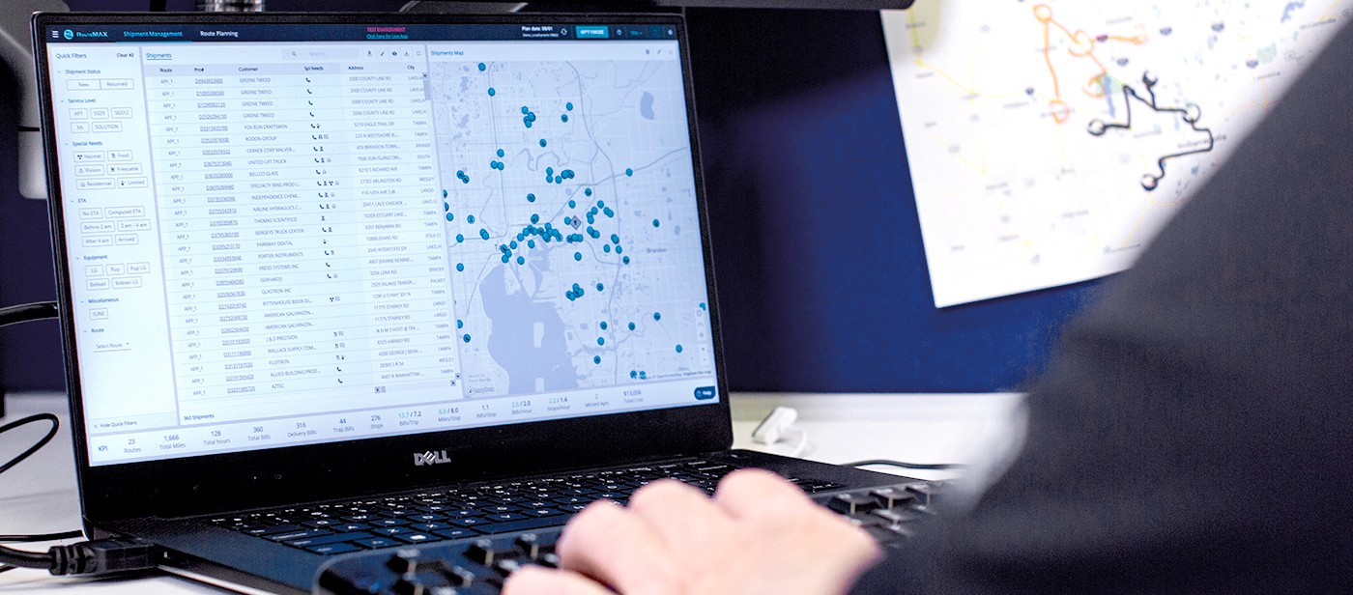
Meeting all customer requirements while minimizing cost is always the goal. To get the job done, planners need a workflow-based system that can replace all planning steps, using a map-based tool. The platform should support the visual- and attribute-based grouping of shipments and automatically process all calculations to reduce user workload. Bullet-proof systems require cloud-based capability that can scale and integrate seamlessly with a carrier’s legacy system. In addition, there must be no perceivable time lags and only minimal setup work required of the carrier’s IT staff.
Technology company Optym has been working with LTL carriers for almost 10 years to solve their planning and scheduling problems. With deep insight into LTL operations and decades of algorithm, machine learning and AI experience, we’ve developed a solution named RouteMAX.
Within 2-4 minutes (typical time for a few hundred bills), RouteMAX determines the best set of routes and communicates it to the inbound dock crew, so they can load accordingly and meet all your customer appointments and guaranteed deliveries — while saving miles and man-hours in the process. To learn more about it, please visit us at www.RouteMAX.com.

