FH® Episodes of Care Benchmarks Demonstration Video Script

Scene | Video | Audio
1 | https://www.shutterstock.com/image-photo/health-care-cost-concept-medical-bill-473248675?src=DTKndXrsg4eXOapneA_VXA-1-25 | An episode of care is the full range of procedures associated with beginning-to-end treatment for common illnesses, chronic conditions and surgeries. As billing for episodes of care becomes more popular in healthcare, both payors and providers are asking: How much does a patient episode of care actually cost? How do you factor in comorbidities and risk factors? How can you compare allowed and charged amounts?
2 | [Title slide reading:]  FH® Episodes of Care Benchmarks | Finally, there’s a solution that can give you a comprehensive view of actual healthcare costs for episodes of care in your geographic area. With FH® Episodes of Care Benchmarks, you get essential insights into value-based reimbursement, budgeting, network building and more.
3 | A screenshot of the interface of the Episode Service Estimator (beginning of live video footage?); or show the application being opened and readied for use | FH Episodes of Care Benchmarks is easy to use. And, you don’t need to be connected to the internet; it is a self-contained application. Here’s how it works.
4 | 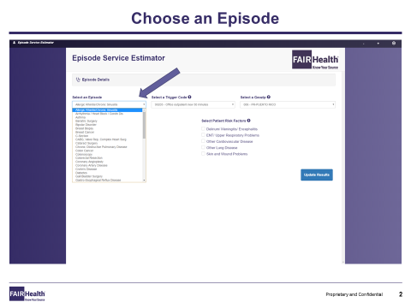 | First, choose an episode of care. You can select from over 40. We’ll pick knee arthroscopy as an easy example.
5 | 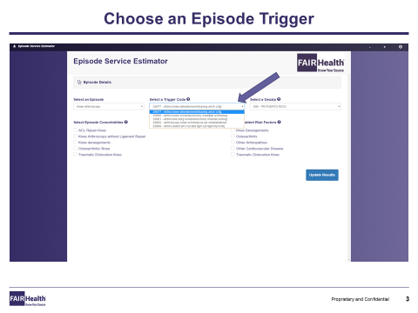 | Next, select an episode trigger code, or driving initiator, that is the initiating factor for the episode—for example, knee arthroscopy with a meniscectomy and medial and lateral shaving.
6 | 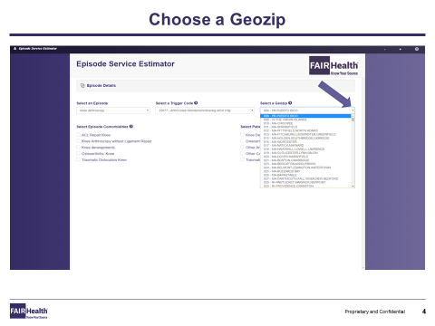 | Now you can choose your geozip. A geozip is a geographical area that tends to track with the first three digits of a zip code. You can select the geozip either by typing it in, or by using the drop-down menu. In this case, we’re going to select Manhattan, which is represented by the one-zero-zero [100] geozip.
7 | 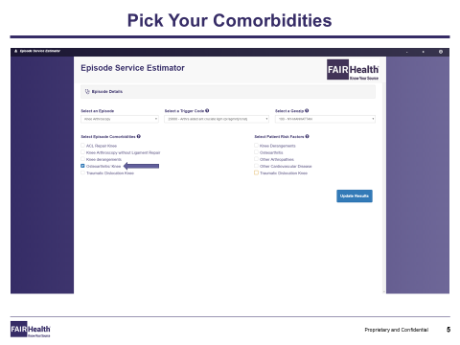 | FH Episodes of Care Benchmarks gives you the option of selecting up to five of the most commonly occurring comorbidities and risk factors associated with the chosen episode of care.  In this instance, the comorbidities we’ll select are knee osteoarthritis and traumatic dislocation of the knee.
8 | 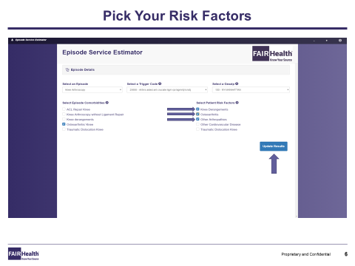 | As for risk factors, we’ll pick these: osteoarthritis and other cardiovascular disease.
9 | 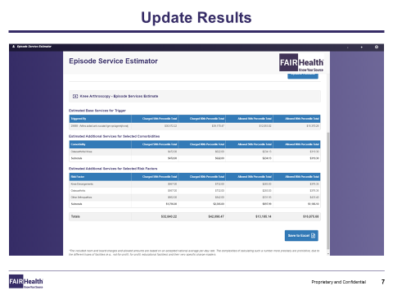 | Now that we’ve chosen all of our variables, let’s go ahead and view our results. We can see the total costs for the base services for the trigger code. We can see the added costs associated with the comorbidities and risk factors we have chosen. We can view the line-item figures for both allowed and charged amounts at the 50th and 80th percentile level. A significant benefit. We also can see the total episode cost.  As you can see, FH Episodes of Care Benchmarks displays all the results in a clean, accessible visual format.
10 | 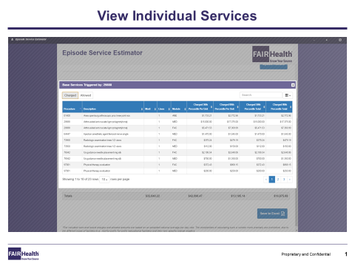 | When you click on any of the line-item services, a new window opens up to display detailed information. For example, clicking on the first line shows you the individual services included in the episode of care, minus any comorbidities and/or risk factors.  You can see each procedure code, its description and its modifier, if any. The column labeled “Lines” lists the number of times the service was delivered, as calculated by our FH Episodes of Care Benchmarks algorithm. The “Module” column refers to which of the FH Benchmarks was used to assess the cost. On the right, you can see broken out the 50th and 80th percentile charges per unit, plus the 50th and 80th percentile total charges.
11 | 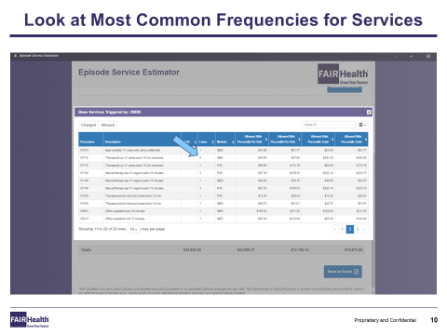 | Let’s say you want to examine how often a service typically occurs in the episode of care. FH Episodes of Care Benchmarks enables you to do that quickly.
12 | 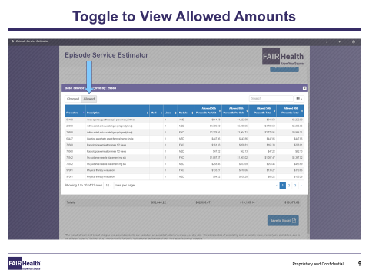 | You can easily switch between allowed and charged amounts for greater clarity. Let’s investigate allowed amounts.
13 | 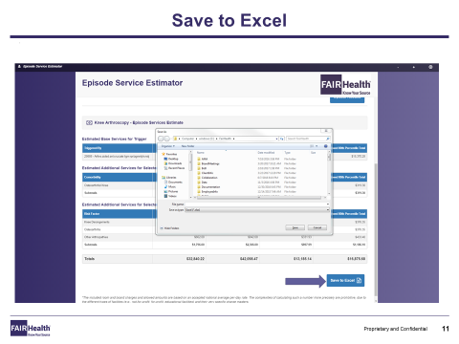 | Saving the data to Excel will allow you to customize the results. To save the data for this episode of care to Excel, just click on the blue “Save to Excel” button.
14 | 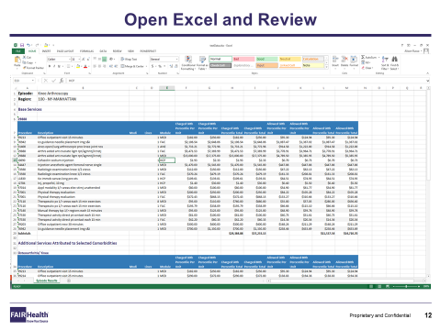 | By opening up your new Excel file, you can review the results.
15 | 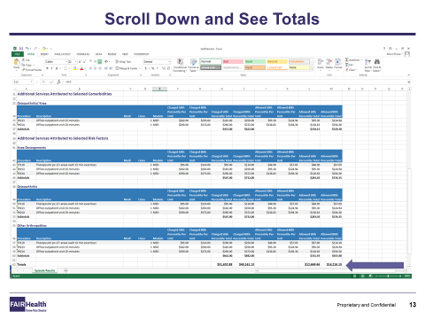 | To see totals, simply scroll down and there they are.
16 | 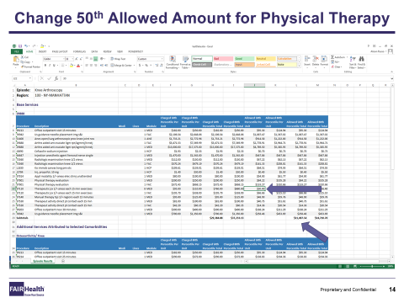 | Now you can customize the results. Let’s say you want to change the 50th percentile allowed amount for physical therapy to $30 so you can calculate the impact of a hypothetical new price. Just go into the cell and replace the number.
17 | 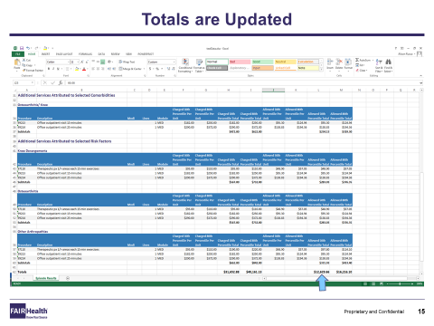 | FH Episodes of Care Benchmarks automatically updates your totals. See how easy it is to use?
18 | 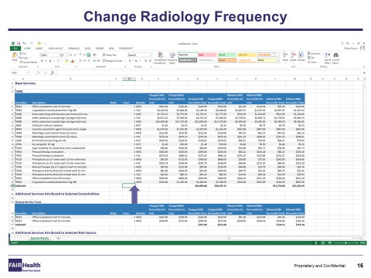 | Now you’ve decided that you want to change the radiology frequency. Go into the assigned cell and alter the number.
19 | 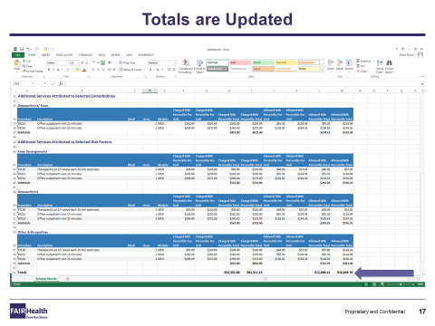 | You can view updated totals immediately.
20 | 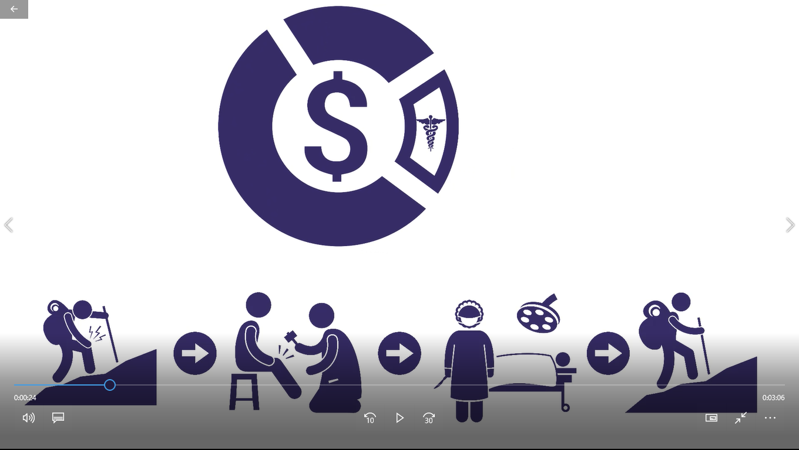  This image of an EOC of a man who experiences knee pain while hiking is taken from the 8-1-17 EOC promo video. | You can see how straightforward it is to use FH Episodes of Care Benchmarks. Our Episode Service Estimator interface makes it easy to choose an episode of care, choose the trigger code and select comorbidities and risk factors.  Once you make all the selections, you can view the results for both allowed and charged amounts at the 50th and 80th percentile levels, including per-unit costs. You also can download the file in Excel and change variables. And, the program always calculates totals automatically for you.
21 | https://www.shutterstock.com/image-vector/financial-report-vector-icon-576794359?src=1EZGzaRJrpgJ8QNCUsde0A-1-12 | Think of how FH Episodes of Care Benchmarks can support your financial planning goals. No other tool like it is available in the marketplace.
22 | [FAIR Health logo with contact info]  Onscreen:  FAIR Health is the only independent nonprofit certified and licensed by the Altarum Institute to operate its PROMETHEUS Payment® model, which is used to identify the services that make up each episode. | If you have any questions about FH Episodes of Care Benchmarks and the value it can bring to your organization, contact FAIR Health at  info@fairhealth.org or call 855-301-3247.

