FH® Online Marketing Video Script

Scene | Video | Audio
1 | 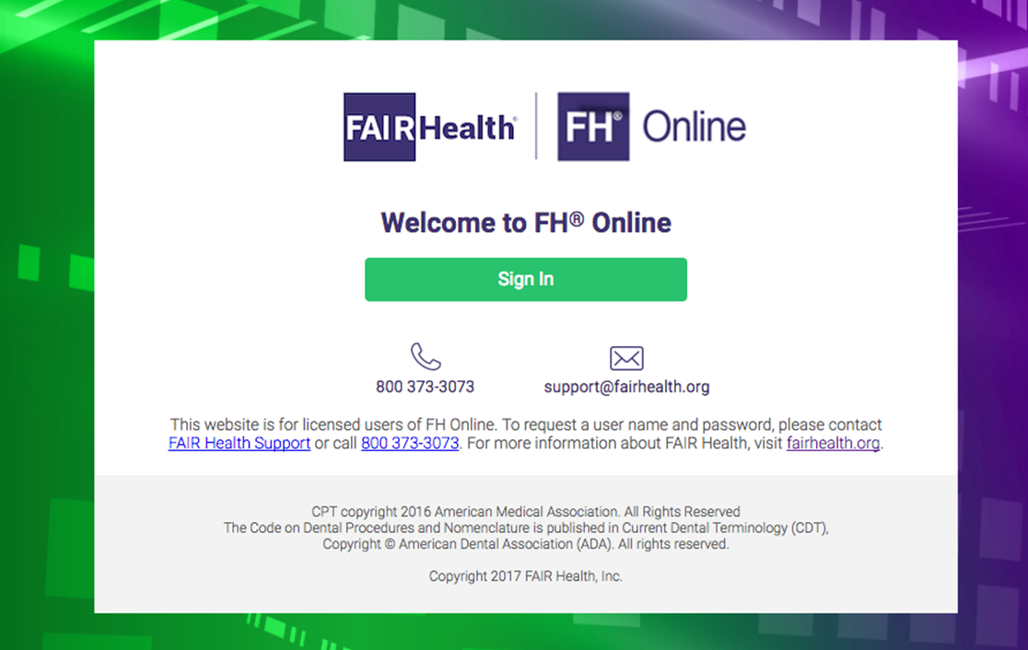 | It’s your job to track down geographically specific cost information for medical and dental procedures. But where can you find a reliable data source?  Fortunately, FAIR Health offers FH Online, a cost lookup tool based on the nation’s largest collection of healthcare claims data.
2 | [Onscreen:]  FH Charge Benchmarks:  - FH Charge Medical;  - FH Charge Dental;  - FH Charge Anesthesia;  - FH Charge Inpatient Facility;  - FH Charge Outpatient Facility;  - FH Charge ASC Facility; and  - FH Charge HCPCS  FH Allowed Benchmarks:  - FH Allowed Medical;  - FH Allowed Dental;  - FH Allowed Anesthesia;  - FH Allowed Outpatient Facility; and  - FH Allowed HCPCS.  FH Medicare GapFill PLUS | When you sign up for FH Online, you get access to a broad selection of our service-specific FH Charge and FH Allowed Benchmarks, as well as FH Medicare GapFill PLUS.  .
3 | Show the program in use, live. The action on the screen will track the indicated steps in the narration. | When you assess fees for a given procedure, you can choose from over 10,000 procedure codes in 493 distinct geographic areas across the US. You can look up a single code, multiple codes, or a range of codes. You can also locate a code by number or keyword.  You can select the current release date or prior releases, if you want to research claims data from the past.  You get access to a range of benchmark values from the 50th to 95th percentiles for each procedure code/geographic area combination. In certain formats, you can also see the mean (average) median (middle) and mode (most frequently occurring) charge.  You can easily look up additional codes or compare rates from older releases.  As an added benefit, it’s simple to download results to a PDF or Excel file.  With FH Online, you can research:  - Facility costs;  - Inpatient or outpatient facility charges;  - Additional charges, such as anesthesia; and  - Durable medical equipment costs.
4 | https://www.shutterstock.com/image-photo/busy-business-woman-black-suite-white-357305144?src=MNvVn1dcVv_AinA2UztSEg-1-7 | FH Online is ideal for claims administrators and customer service representatives, and for healthcare professionals who develop life care plans or settlement agreements.  It’s suited for anyone who needs to quickly look up benchmarks to research costs, respond to plan member inquiries and find information needed for appeals.
5 | [Onscreen:]  Your Choice:  - Unlimited Data Plan  - Subscription Model – Limited Data Range | If you need the full range of our data, you can purchase an unlimited data license.  If you only need to access a limited range of data, we offer a variety of subscription packages, which give you access to a certain number of searches. And, if you run out of searches, it’s easy to renew your subscription.
6 | 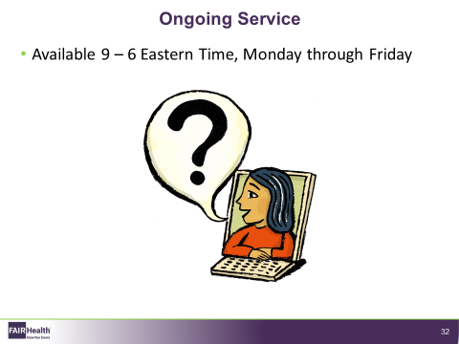 | Our client services representatives are available by phone or email to assist you if you have questions about the data or using the FH Online website. You can reach them weekdays between 9 am to 6 pm Eastern time.
7 | [FAIR Health logo with contact information] | FH Online can enable you to find accurate cost estimates for all the procedures you need in just a few minutes.  To learn more about the power of FH Online, contact us and see how we can support your goals.  Contact FAIR Health at  info@fairhealth.org or call 855-301-3247.

