AMA Advisory Group
[put your logo here?]

A Proposal for the DR Management of the Open Joint Stock Company Norilsk Nickel’s ADR Program

Table of Contents

Table of Contents X
Executive Summary and Results X
Overview of the DR Market (Globally and in Russia) X
- DR Liquidity X
- New Amendments to the Regulatory Framework X
- Market Statistics on the Buy-side’s View of DRs X
- Top Institutional Investors That Buy DRs X

Overview of Depositary Banks (Globally and in Russia)

- The Role of a Depositary Bank X
- Market Overview (Competition) X
- Depositary Banks’ Revenues X
- Reimbursement Arrangements X
- Scope of Services X
- Pricing Model X
- Transparency (FX fees) X
Assessment of the Current Engagement Letter Between Norilsk Nickel and BNY Mellon (“BNYM”)
- Analysis of the Economic Value of the Current DR Arrangement X
- Terms and Conditions of the Current Arrangement X
- Assessment of Core Services Rendered by BNYM X
- Voting X
- Corporate Actions (Buyback) X
- Dividends Distribution X
- Assessment of the DR Relationship Between BNYM and Norilsk Nickel’s Major
Shareholders X
Assessment of DR Proposals for the New DR Relationship
- Selection of Criteria X
- Pricing Model (Reimbursement Arrangements X
- Core Services X
- Additional Services (Investor Relations, Transfer Agent, Post-Meeting Assessment) X
- Special Arrangements X
- Tax Reclamation Services X
- Assessment of the Action Plan for Processing Dividends and Proxies in Accordance
With the New Disclosure Law X
AMAG’s Independent Recommendation
- Certification (AMAG’s Expertise) X
- Summary of Work Done X
- Conclusion X
Appendices X

Executive Summary and Results
XXXXXXXXXXXXXXXXXXXXXXXXXXXXXXXXXXXXXXXXXXXXXXXXXXXXXX

Overview of the DR Market (DR Liquidity)

As of June 2013, overall worldwide trading volume for depositary receipts (“DRs”) accounted to 72 billion DRs, compared to 78 billion DRs at June 2012, the same time the prior year. There was a decrease of 6.0 billion DRs, or 8% YTY. In light of market turmoil, the overall size of DR trading volume decreased across all major venues and regions. Regarding the biggest drops in DR trading volume, NYSE Euronext (“NYSE”) reported an almost 2.5 billion decrease, while the London Stock Exchange (“LSE”) recorded a 2.3 billion decrease.
The largest drop in DR trading volume was among Brazilian issuers (1.5 billion DRs) and French issuers (1.5 billion DRs). They both accounted for the majority of the NYSE’s decreased trading volume. Also, a significant decrease in trading volumes from Russian issuers (2.3 billion DRs) accounted for the majority of the LSE’s decrease trading volume.
Based on trading statistics, NASDAQ did not suffer as much as NYSE and LSE during the first half of 2013. Overall trading volumes on NASDAQ were down mainly due to a drop in trading volumes of companies from Hong Kong (260 million DRs) and China (235 million DRs). This drop was offset by an increase in trading volumes of UK issuers (340 million DRs).

The Top Ten Most Liquid Programs
Issuer | Country | Exchange | YTD June 2013 Value (USD Billions)
Vale SA | Brazil | NYSE EuroNext | 57
Petroleo Brasileiro SA (Petrobras) | Brazil | NYSE Euronext | 54
Baidu, Inc. | China | NASDAQ | 50
Vodafone Group PLC | UK | NASDAQ | 40
BP PLC | UK | NYSE Euronext | 33
Royal Dutch Shell PLC | Netherlands | NYSE Euronext | 32
Sberbank of Russia | Russia | LSE | 29
Gazprom OAO | Russia | LSE | 29
Taiwan Semiconductor Manufacturing Co Ltd | Taiwan | NYSE Euronext | 23
America Movil S.A.B. | Mexico | NYSE Euronext | 23
Source: Bloomberg Financial Markets and Depositary Data Interchange

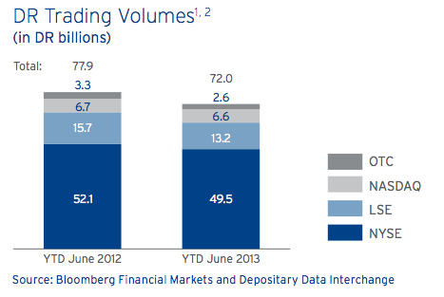
I will add more graphs.

Main Benefits of Holding DRs Versus Ordinary Shares
Most institutional investors have the option of holding either DRs or underlying shares at any particular point in time. While they may have the mechanism to buy the ordinary shares of Russian companies and hold their positions with local custodians, there are several complex factors in place that affect their purchase decisions.
Guidelines and investment objectives: Many US investment institutions are subject to restrictions on holding their positions outside the US. In particular, this may place limitations on their ability to hold ordinary shares in foreign custody. As a result, these institutional investors are more likely to purchase DRs.
Liquidity: Depending on which market is more liquid, investors may choose to purchase DRs or underlying shares. Supply and demand is regulated by the issuance and cancellation mechanism underlying the creation of DRs. Based on trading volume statistics, the DR market for Russian companies is higher than the local market. To show the current split between DRs and the local market, 60% of the daily trading volume of Russian blue chip companies is settled on the London Stock Exchange, while 40% is settled on the Moscow Stock Exchange.
Transaction costs: One of the main advantages of buying DRs is the absence of foreign custody fees, which range from between 10-35 basis points per year, based on the value of the investment. Before purchasing DRs, investors should conduct the cost/benefit analysis of holding underlying securities or DRs.
Collateral of DRs: The majority of Russian oligarchs hold their equity stakes in the form of DRs via offshore vehicles under nominee accounts. These nominee accounts are not transparent to the market. When the oligarchs make a loan (syndicated or club) from foreign banks, a lead arranger (financial institution) of the loan prefers to take DRs as collateral rather than ordinary shares. In many cases, banks offer a slightly better loan terms when a borrower uses DR as securities collateral.
New Amendments in the Russian Regulatory Framework
Disclosure Requirements for Dividends and Voting
In 2012, the Russian Federation introduced major changes to the Russian securities law that had a significant impact on DR programs. Starting January 1, 2013, a depositary bank was required to custodize the underlying Russian shares of its Russian programs in a “DR Program Depo Account.” A depositary bank must open a DR Program Depo Account with a Russian custodian that in turn holds a nominee account in the new Central Securities Depository (CSD). In light of the new law, depositary banks must establish a DR Program Depo Account and move the shares underlying its DRs within one year of establishing a National Settlement Depositary (“NSD”) as the CSD (i.e., not later than November 6, 2013). [November 6, 2013 has passed. Does this need to be revised? Has NN already established a Depo account? --WW ]

On January 1, 2014, a new “cascade” dividend payment mechanism was introduced to the market so Russian issuers can pay dividends to custodians and depositary banks, which in turn must transfer dividends to underlying beneficial owners (“UBOs”). Based on this new law, UBOs will not be required to make disclosures to receive dividends. However, UBOs must make their disclosures to vote at a shareholders’ meeting.

We believe there will be a short timeframe between the opening of the DR Program Depo Account and January 1, 2014, when compulsory UBO disclosure requirements for both dividend payments and voting will apply in accordance with the Federal Law 415-FZ. [Is this last sentence necessary, since January 1, 2014 has passed? Or is there a nuance to this new securities law that I’m not grasping? Should the sentence be rewritten? -- WW]

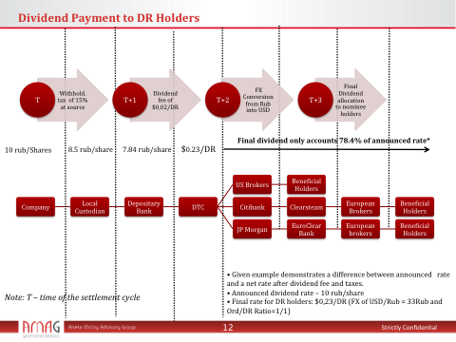

Overview of Depositary Banks
The Role of a Depositary Bank
A depositary bank must:
- Maintain a register of DR holders so it can communicate with them about the DR program registrar and transfer agent
- Process corporate actions
- Act as the paying agent, processing dividend payments or other entitlements for DR holders
- Provide ongoing account management support to the Issuer
- Offer value-added services in investor relations (“IR”) and public relations (“PR”).
The depositary bank plays an essential role for a company that wants to expand its capital market activities outside a local market and take advantage of all the benefits of depositary receipts. Currently, there are four depositary banks that control the DR market—BNY Mellon, Deutsche Bank, JP Morgan and Citibank. The company and the depositary enter into a relationship by signing 1) a Deposit Agreement that sets forth the terms and conditions of depositary receipts and by signing 2) an Engagement Letter that sets forth a commercial arrangement and other non-financial services offered by the depositary bank.
Market Overview (Competition)
There are four depositary banks globally: BNY Mellon, Deutsche Bank, JP Morgan and Citibank. BNY Mellon is the largest depositary bank based on the market share for sponsored DR programs.
Global Market Share of Sponsored DR Programs

Reimbursement Arrangements
Over the years, the DR market has evolved so that depositary banks share a certain percentage of their revenues with companies in a form of a financial reimbursement (“Reimbursement”). For an issuer like Norilsk, the reimbursement allocation plays an essential role in the process of selecting a depositary bank. The main purpose of the reimbursement is to cover the company’s expenses rendered in connection with the improvement of investor relations, PR, capital markets-related projects, and corporate governance.
There are two ways depositary banks can pay the reimbursement. The first option is to reimburse the company directly with a fixed amount or allocate a certain percentage from the bank’s revenue. The second option is to pay directly to third-party vendors on behalf of a company by utilizing a company’s reimbursement budget.
From a regulatory perspective, all foreign companies listed in the US market (NYSE and NASDAQ) must disclose the total value of reimbursement payments received from the depositary bank in a 20-F report. This rule does not apply to issuers listed on the London Stock Exchange and other European stock exchanges.
In addition to the payment method, the company has the ability to take the reimbursement in the form of an upfront payment based on an bank’s estimated future revenue or to receive the reimbursement on an annual basis during the duration of terms of an Engagement Letter between the company and depositary bank. The upfront payment is usually employed during IPOs, when the depositary bank pays the company the upfront payment to cover IPO-related expenses. The revenue-sharing model is usually employed when the company has already established a DR program and prefers to change a pricing arrangement with the depositary bank or to re-appoint another depositary bank.

A Short Overview of Reimbursement | 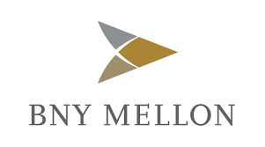 | 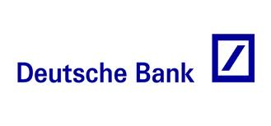 |  | Citibank logo
Revenue Sharing | Yes (Gross) | Yes (Net) | Yes (Gross/Net) | Yes (Gross/Net)
Upfront Payment | Yes | Yes | Yes | Yes
Payment to third-party vendors | Yes (Flexible Rule) | Yes | Yes, but with certain limitations with respect to paying to third-party vendors) | Yes

The Depositary Bank’s Revenue
Depositary banks generate revenues by charging DR holders depositary fees. All depositary fees are listed in Deposit Agreement. Depositary banks charge the following fees:
- Issuance and Cancellation Fees of up to $0.05 per DR
- Dividend Processing Fees of up to US$0.02 per DR
- Depositary Service Fees (“DSF”) up to US$0.02 per DR
- Register Inspection Fees up to $0.01 per DR
- Tax Reclamation Fees up to $0.005 per DR.

Not all fees are fully transparent and disclosed to companies and DR holders, especially when a financial reimbursement is tied to the depositary bank’s revenue. If the depositary bank allocates a percentage from its revenue to the company, the depositary bank has an incentive to disclose the smallest revenue amount possible. There are several ways the depositary bank can manipulate its revenue figures.
a) Cross-Border Activities:
When a broker deposits a large block of underlying shares to issue DRs, he or she always asks for a discount on the issuance fee from the depositary bank. If the block trade exceeds a value of more than $100 million, the depositary bank can discount its fee from $0.05 to $0.03 per DR. The size of the fee scale depends on the value of the trade. Every depositary bank has its own fee scale for the issuance fee, but they are relatively same.
At the end of a calendar year, when a depositary bank can reconcile gross revenue to calculate a reimbursement amount, the depositary bank will average the issuance fee by taking the smallest fee for the past 12 months. It is almost impossible for the company to verify the depositary bank’s revenue derived from cross-border activity. It is essential for the company to request from the depositary bank a monthly trading report, which reveals the issuance fee, the name of a broker, and the number of DRs issued.
b) Tax Reclamation Activity
The depositary bank offers tax reclamation services for eligible DR holders. When investors receive income such dividends from holding DRs, they are often taxed at a high withholding rate— the “statutory” rate. DR holders may be eligible under double-tax treaties to reclaim taxes withheld in a local market. For this service, the depositary bank charges $0.005 per DR. We have experienced a few cases where the depositary bank did not factor in revenue derived from tax reclamation services to calculate reimbursement.
Pricing Model
Most DR programs are complex multi-party arrangements between the Issuer, the depositary bank, and DR holders, based on estimated future cash flows stemming from different sources (the annual fee, the dividend payment fee, the conversion fee, etc.). This results in low transparency of economic benefits, especially concerning reimbursement arrangements between the depositary bank and the Issuer. Our experience indicates that most the DR issuers could substantially increase reimbursement amounts from their depositary banks. A depositary bank may be earning substantial profits that are not equitably shared with, or made available to, a company and/or are taken by the depositary at the expense of DR holders. Although many DR issuers receive financial contributions and expense reimbursements from their depositary banks, most companies fail to derive the full value they are due from their DR programs.
Depositary banks price the reimbursement multiple based on the following parameters:
- The number of DRs outstanding
- Corporate actions (ratio changes on DRs, SPO, buybacks, share splits)
- A total fixed fee they can charge DR holders per year
- The duration of the contract terms
- The Foreign Ownership Limit
- The frequency of dividend payments
- The size of DR positions held by strategic investors. Most strategic investors or members of top management who hold a significant stake in the company request a significant discount on their DR positions. As a result, depositary banks have to factor in offered discounts to their P&L.
Since many variables can impact the pricing model, depositary banks employ their own standard pricing multiple, so companies can compare the pricing multiple of all four depositary banks.
- The first pricing multiple is a percentage (%) of the depositary’s revenue. This multiple can be priced based on the depositary bank’s net or gross revenue. Based on our experience, many companies fall into a trap by signing an Engagement Letter where the reimbursement’s pricing is structured under the net basis. We suggest that companies should always ask for the gross revenue sharing or, at least, calculate the difference of the percentage allocation between gross and net revenue-sharing before signing the Agreement.

- The second pricing multiple is based on a certain amount reimbursed per every one (1) million DRs issued. For example, the depositary bank can price the reimbursement based on $140,000 per one million DRs issued or transferred.
As the main guideline for evaluating depositary banks, a company should ask the following questions:
- What a percent of the reimbursement allocation is taken from a depositary bank’s gross revenue?
- How much does the depositary bank charge DR holders?
- How is the depositary positioned with investors and other global market participants?
- What peers in your region and worldwide are excellent examples of how the depositary has managed liquid DR programs?
- What is the depositary bank’s client portfolio?
- Does the depositary bank provide investor relations and corporate governance services? If yes, in what form?
- Does the depositary bank have its own custody branch?
- How many people work in a local office?

Based on our market intelligence, we have compiled a table (below) that summarizes the reimbursement allocation and annual fees that depositary banks charge DR holders in connection with Russian DR issuers. In addition to the table, we have constructed a graph to analyze the correlation between two variables and locate where each company is positioned on the graph. The purpose of the graph shown below is to demonstrate the extent of the deviation from the line and the size of the correlation between the fees and reimbursement allocation.

№ | Компания | % возмещения от выручки банка депозитария | Ежегодная фиксированная Комиссия с инвесторов ($/ДР в год) | Объем Программы ДР (колличество в миллионы ДР)
1 | Газпром | 35% | $0,02 | 2200
2 | Сбербанк | 75% | $0,04 | 1200
3 | ВТБ | 75% | $0,03 | 900
4 | Лукойл | 45% | $0,02 | 720
5 | Сургутнефтегаз | 60% | $0,035 | 400
6 | Мегафон* | 90% | $0,03 | 120
7 | Русгидро | 60% | $0,02 | 340
8 | Уралкалий | 60% | $0,03 | 98
9 | Татнефть | 50% | $0,04 | 108
10 | Киви* | 90% | $0,04 | 60
11 | ММК* | 85% | $0,04 | 65
12 | Черкизово* | 95% | $0,03 | 55
13 | ТМК | 85% | $0,03 | 80
14 | Интер Рао | 75% | $0,02 | TBD
15 | Норильск Никель | 80% | $0,03 | 650

* Note: Reimbursement allocation was paid in the form of an upfront payment based on a depositary’s future projected revenue stream.
Scope of Services
To support a depositary receipt program, depositary banks provide companies with access to the following value-added services:
- The depositary bank acts as a proxy agent between the company and DR holders.
- Investor relations (IR) counsel — providing a team of former in-house corporate IR executives who consult and support clients in all aspects of their global IR objectives.
Assessment of the Current Engagement Letter Between Norilsk Nickel and BNYM
In 2009, Norilsk Nickel and BNY Mellon signed a Side Letter that allowed Norilsk Nickel and BNY Mellon to change financial arrangements and the terms and condition of the Engagement Letter dated November 2001. BNY Mellon agreed to reimburse the company $25 million as an upfront payment and share 10% of its gross revenue. In return, BNY Mellon asked Norilsk Nickel for permission to charge $0.03 per DR on DR holders. The fee of $0.03 consists of the Dividend Fee of $0.02 and Depositary Service Fee (DSF) of $0.01
Structure of the Current DR Agreement Between BNY Mellon and Norilsk Nickel
- Side Letter dated November 31, 2009
- Duration of the Side Letter: 5 years
- Financial terms of the Side letter:
- $25 million (upfront payment)
- 10% revenue sharing of BNY Mellon’s gross revenue per year

- Depositary Fees:
a) Issuance Fee: $0.05 per DR
b) Cancelation Fee: $0.05 per DR
c) Dividend Fee: $0.02 per DR
d) Depositary Service Fee: $0.01 per DR

Based on our calculation, BNY Mellon generates approximately $____ per year from the Norilsk Nickel DR program. In return, BNYM allocates ___ million to the company as an annual reimbursement. This allocation split is designed in favor of BNYM, since ____% of the gross revenue is being kept by BNYM as the depositary bank, and only ____ is allocated in aggregate to Norilsk Nickel in the form of an annual reimbursement payment. We factored in the upfront payment in our annual percentage calculation. Compared to the treatment of other Russian companies, BNYM’s 2009 proposal was far below DR market standards. Such unfavorable terms were agreed to due to an ongoing contested proxy at the company. Under the old terms, BNYM preformed many requests generated by the company that were not a part of the official agreement.
BNYM Proposal
Financial Section
Reimbursement (Revenue-sharing model):  BNYM agrees to reimburse the company up to 80% of its gross revenue. | Reimbursement (Revenue-sharing model):  BNYM’s revenue to be derived from issuance and cancelation activities will NOT be factored in as part of the reimbursement calculation. BNYM will keep that part of the revenue for itself without sharing it with the company.
Upfront reimbursement:  Yes, $10,000,000 (Flexible terms) | Upfront reimbursement:  We suggest that the company maximize the upfront payment due to the discounted cash flow (DCF) model. The future value of the ongoing reimbursement will be discounted by ______.
Discount to Strategic Shareholders:  - Strategic shareholders will be excluded from dividend fees related to interim dividends.  - Strategic shareholders will be charged a fee of $0.01 per DR on an annual dividend.  - Strategic shareholders will be charged a fee of $0.01 per DR on Depositary Service Fees.  - Strategic shareholders will be excluded from tax reclamation fees. | Discount to Strategic Shareholders:  Although BNYM agrees to extend a discount to Norilsk Nickel’s strategic shareholders, it will charge a depositary fee against their DR positions. Overall, Deutsche Bank agrees not to charge its DR fees against positions held by strategic shareholders.
Non-Financial Section
Local Presence:  - BNYM has a Russian representative office in Moscow, managed by Irina Baichorova. She is one of the best DR experts in the industry and has significant DR experience.  DR Functional Structure:  The DR team consists of the following business units:  - Regional Management and Client Management  - DR Market Solution  - Legal & Transaction Structuring Group  - Product Management  - Broker Services  - Corporate Actions  Proxy and Corporate Action services.  - BNYM has the best Corporate Action and Proxy team in the DR industry. Based on its proposal, BNYM managed several large corporate actions in Russia and globally, including the past contested proxy for Norilsk Nickel and other Russian companies. There are few Russian speakers at BNYM’s proxy and corporate action team.  Value-added investor relations services:  BNYM has 14 IR specialists who can help Norilsk Nickel with IR-related projects. | Local Presence:  - Compared to other depositary banks, BNYM does not have a full subsidiary office in Moscow. As a result, BNYM cannot perform full operational duties in Russia.  - None  DR Functional Structure:  - None  Proxy and Corporate Action Services.  BNYM has one of the best proxy and corporate actions specialist in the DR industry.  Value-added investor relations services:  - All non-financial services provided by depositary banks carry out the same level of service, except proxy and corporate actions. Although all depositary banks offer IR support, their IR capabilities are limited in terms of executing and delivering IR-related projects.

Below is a comparison of BNYM’s 2013 DR proposal with the 2009 DR arrangements between BNYM and Norilsk Nickel.
DR Pricing:

Termination Clause:
In addition to the pricing component, the company was able to change the following provisions in the current contract:
[What are the provisions that are being changed? -- WW]
BNYM’s Overall Score – 8.95
In our scoring methodology, the minimum is 0, with 10 points as the maximum. For each section of the proposal, we have allocated weights according to the level of importance a given factor has in the relationship between the depositary bank and an issuer.
Item | Score | Percentage (%) allocation | Total Score
Reimbursement allocation (structure including upfront reimbursement) | 8 | 50% | 4
Discount to strategic shareholders | 7 | 15% | 1.05
Proxy/Corporate Action related services | 10 | 10% | 1
Client Support (RM’s coverage) | 8 | 10% | 0.8
Local presence | 5 | 5% | 0.25
IR Services (including access to DR systems, IPREO or TR’s systems) | 7 | 5% | 0.35
* Historical Relationship (Extra bonus points) | 10 | 10% | 1
Termination/Structure of the new agreement (Including termination clause) | 10 | 5% | 0.5

The Deutsche Bank Proposal
On ___ , the company received a DR proposal from Deutsche Bank (“DB”). We carefully reviewed it and identified its key advantages and disadvantages. In the table below, we provide a short summary of the proposal’s strong and weak points.
Non-Financial Section
Local Presence:  - DB has a Russian subsidiary entity in Moscow.  - The total number of employees in DB’s Moscow office is XXXX. There are two Relationship Managers in DB’s Moscow Office. | DB Credentials:  We found several mistakes in the portfolio of DB clients in Russia. (See page 5.) FSK and Kalina are no longer DB’s clients.
Awards:  - No.1 ranked US Transfer Agent, seamlessly servicing Norilsk Nickel registered holders.  - “Best Depositary Receipt (DR) Program  in EMEA” for 2011 and 2012. Deutsche  Bank received the EMEA Finance Achievement Award for its role in the Kcell JSC Global Depositary Receipt (GDR) program from Kazakhstan in 2012 and the Nomos Bank Global Depositary Receipt (GDR) program from Russia in 2011. | Awards:  Despite all of its listed awards, DB is ranked the second depositary bank by its market share in Russia and global markets.
DR Functional Structure:  The DR team consists of the following business units:  - RM and Client Management  - DR Market Solution  - Legal & Transaction Structuring Group  - Product Management  - Broker Services  - Corporate Actions | DR Functional Structure  All decision-making power is based in New York/London. The Moscow staff does not have a mandate to make any decisions related to financial matters.
Proxy Service:  DB provides full Proxy Services, including drafting and mailing proxy cards and collecting votes. Also, DB offers on-demand reports on voted/unvoted share positions. | Proxy Service:  - DB does not have extensive experience in proxy contests, as BNYM does.  - We could not locate a detailed action plan with respect to processing the 2014 AGM/EGM in accordance with the new disclosure rule. Also, we could not locate [sentence to be completed – WW]
Value-added Investor Relations Services
There are 7 individuals in the DR Market Solutions department who can provide value-added IR services to Norilsk Nickel.
Financial Section
Reimbursement:  - Option 1: If the annual fees collected from dividend processing and servicing fees are at US$0.02, DB would offer net revenue sharing* at 77% / 23% in favor of Norilsk Nickel.  - Option 2: If the annual fees collected from dividend processing and servicing fees are greater than US$0.02, DB would offer net revenue sharing* at 83% / 17% in favor of Norilsk Nickel. | Upfront Reimbursement:  - There is no clarity on upfront reimbursement.  - In its current proposal, DB made a short note about upfront reimbursement on page 28. (Deutsche Bank would be happy to pay the first year’s estimated revenue-sharing entitlement upfront, and then make appropriate adjustments on the first or second anniversary of Closing.) There is no clarity on the appropriate adjustment, and there is no dollar amount on the upfront reimbursement.  - The revenue-sharing arrangement is based on a net basis. We understood that DB would deduct custody and operating expenses from its annual gross revenue and then allocate a net reimbursement to the Issuer.
IR Budget
DB offers to cover all expenses up to $100,000 per year for IR-related activities. The money can be paid directly to third-party vendors.
Fee structure (discount) on DR positions held by strategic investors:  DB has agreed to waive or rebate the dividend processing and/or annual servicing fees with respect to approximately 320,000,000 ADRs (the "ADR Waiver"). | Fee structure (discount) on positions held by strategic investors:  a) Although DB has agreed to waive annual service and dividend fees, there is no clarity whether this arrangement is applicable to issuance and cancelation activities.  b) Since the annual reimbursement is tied to the depositary’s annual revenue, the available reimbursement to the company will be lower, due to the proposed discount for strategic shareholders.  Note: We have attached a cash-flow model summarizing P&L from each depositary bank.

DB’s Overall Score – 7.9

Item | Score | Percentage allocation | Total Score
Reimbursement allocation (structure including upfront reimbursement) | 8 | 50% | 4
Discount to strategic shareholders | 10 | 15% | 1.5
Proxy/Corporate Action related services | 7 | 10% | 0.7
Client Support (Regional Management coverage) | 7 | 10% | 0.7
Local presence | 8 | 5% | 0.4
IR Services (including access to DR systems, IPREO or TR’s systems) | 7 | 5% | 0.3
Termination/structure of the new agreement (Including termination clause) | 6 | 5% | 0.3

JP Morgan Proposal
On November __ 2013, Norilsk received JP Morgan’s proposal in a form of an email. JPM never submitted an official proposal. Therefore it would be difficult to assess JPM’s non-financial services.
Non-Financial Section
Note: Unfortunately, JPM did not submit a full proposal. Thus, we will not be able to access JPM’s non-financial services.
Financial Solution
- JPM offers revenue sharing based on 90% from its net revenue per year.  - JPM offers upfront reimbursement up to $2,000,0000 within 5 days from signing a new agreement. | - The revenue-sharing model is proposed based on a net basis (not gross). JPM did not clarify a list of expenses they would add to calculate avaialble reimbursement to the Issuer.  - JPM offers the lowest upfront reimbursement. Due to the size of Norilsk Nickel’s DR program, we strongly believe JPM’s offer of $2,000,000 is a low threshold for upfront reimbursement.
Discount to Strategic Shareholders  - JPM has a flexible program with respect to discounting DRs fees on DR positiuons hely by strategic investors. | Discount to Strategic Shareholders  - JPM did not speciy in its proposal details on discount paramenters.  - Based on JPM’s internal compliance, any discounts made to DR holders that hold more than 5% in Norilsk Nickel must be publicly disclosed. This may raise serious concern from minority holders, since it can be classified as preferential treatment of strategic investors.

Overall JPM’s score – 6.95
Item | Score | Percentage allocation | Total Score
Reimbursement allocation (structure including upfront reimbursement) | 9 | 50% | 4.5
Discount to strategic shareholders | 10 | 15% | 1.5
Proxy/Corporate Action related services | 0 | 10% | 0
Client Support (Regional Management’s coverage) | 7 | 10% | 0.7
Local presence | 5 | 5% | 0.25
IR Services (including access to DR systems, IPREO or TR’s systems) | 0 | 5% | 0
Termination/structure of the new agreement (including termination clause) | 0 | 5% | 0

Assessment of DR Proposals for the New DR Relationship

Item: | BNY Mellon | Deutsche Bank | JP Morgan
Upfront reimbursement | $10,000,000 | (First year gross revenue) – $12,000,000-$14,000,000 | $2,000,000
Revenue sharing based on a percentage (%) allocation from a depositary bank’s revenue (gross or net) | 80% (Gross) | - Model 1: If DR fee </= $0,02/DR – 77% (Net)  Model 2: If DR fee >/=$0,03/DR – 83% (Net) | 90% (Net)
Terms for termination of the agreement (including costs to company) | Flexible (no terms) | 5 years, gross negligence only | 5 years, gross negligence only
Discount for shareholders | Yes  - Annual dividends - $0.01  - Interim dividends – $0/DR  - DSF – $0.01/DR | Yes  - Annual dividends - $0/DR  - Interim dividends – $0/DR  - DSF – $0/DR | Yes (no specific parameters are disclosed in the proposal)
DR Fees: | - Issuance and Cancellation Fees of up to $0.05 per DR  - Dividend (Annual) Fees up to US$0.02 per DR  - Dividend (Interim) Fees up to US$0.01 per DR  - Depositary Service Fee (“DSF”) up to US$0.02 per DR  - Tax Reclamation Fee up to $0.005 per DR | - Issuance and Cancellation Fees of up to $0.05 per DR  - Dividend (Annual) Fees of up to US$0.02 per DR  - Dividend (Interim) Fees up to US$0.01 per DR  - Depositary Service Fee (“DSF”) up to US$0.02 per DR  - Register Inspection Fee up to $0.01 per DR  - Tax Reclamation Fee up to $0.005 per DR  Note: DB has a historical tendency to charge RFP of $0.01 per year. | - Issuance and Cancellation Fees of up to $0.05 per DR  - Dividend (Annual) Fee – Unclear  - Depositary Service Fee (“DSF”) - Unclear  - Register Inspection Fee up – Unclear  - Tax Reclamation Fee – Unclear
Additional IR budget | No | Yes, $100,000/year | No
Ongoing services and costs waived | Yes, Proxy & IR | Yes, Proxy & IR | Not disclosed
Proxy Services | Yes, internal proxy solicitation. Large experience in contested proxy battles. | Yes, limited experience in proxy contested battles. DB does NOT offer internal proxy solicitation series. | Yes, not disclosed in the proposal
Number of Russian-speaking DR specialists | 10 people | 4 people | Unclear
Credentials | Gazprom, Lukoil, Surgutneftegas, Sberbank, VTB, MMK

Appendices
APPENDICES

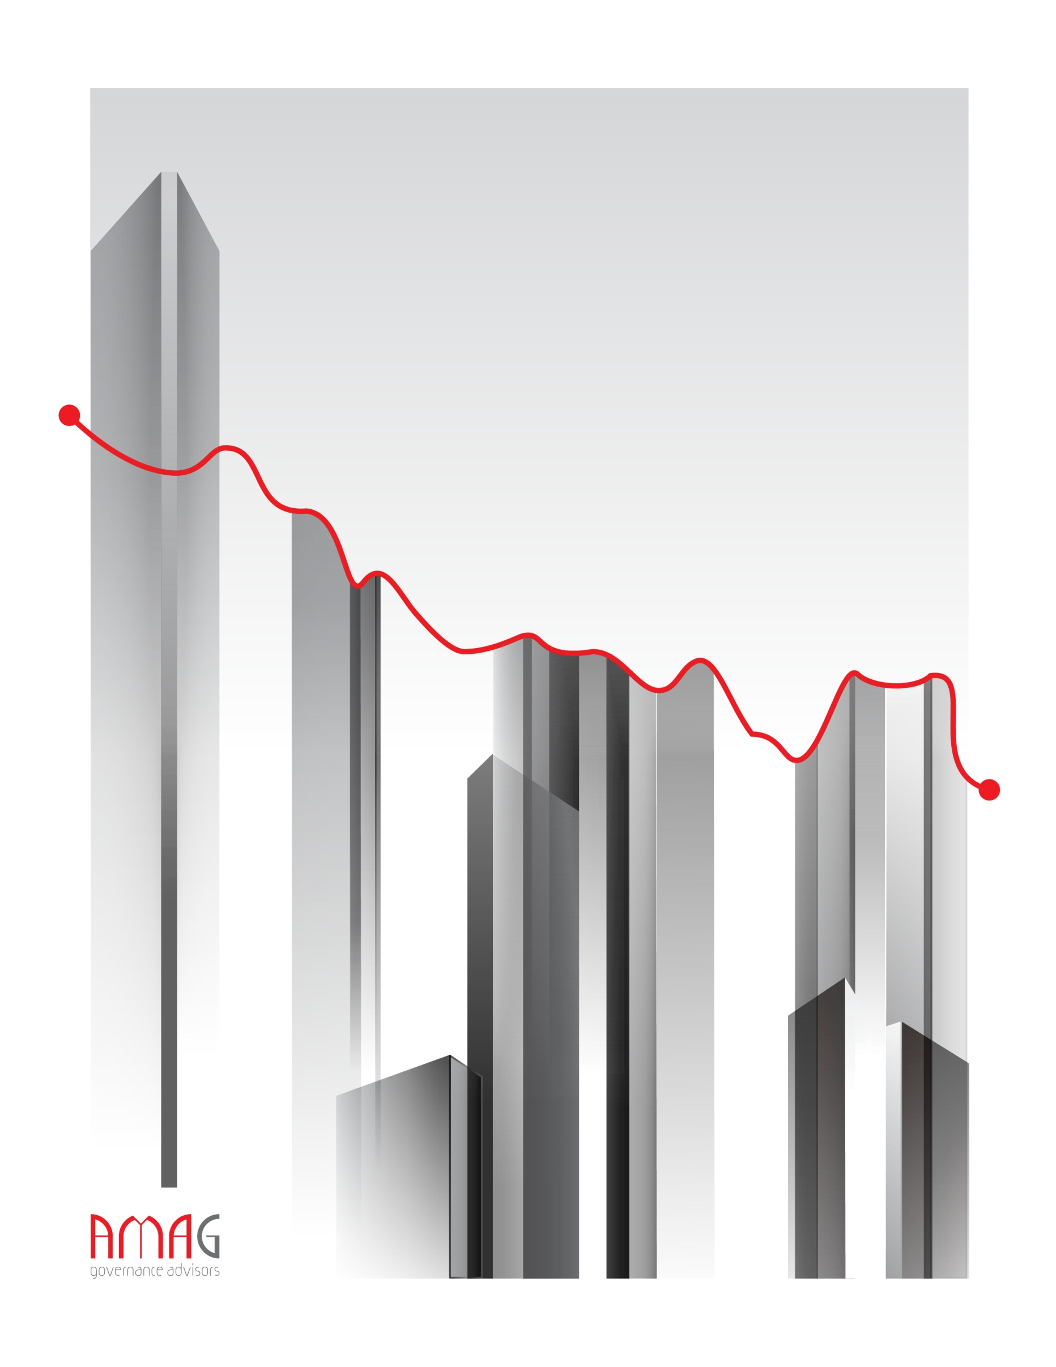
Aneta McCoy Advisory Group
Bolotnikovskaya 36/5
Moscow, Russia 117149
Tel: +7 (909) 918–7197
aneta.mccoy@amadvisorygroup.com
www.amadvisorygroup.com

